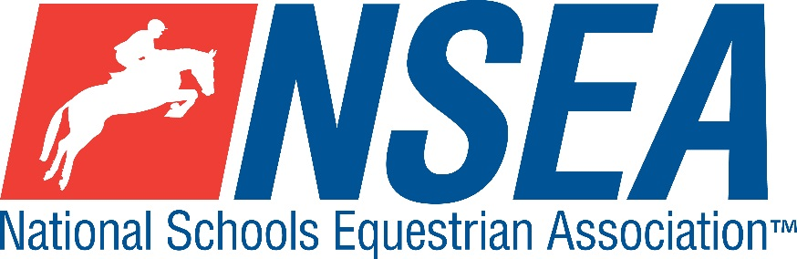

National Schools
NSEA Arena Eventing (Jws) Qualifiers
(Outdoor all weather ‘Fred Arena’)
&
National Schools
NSEA Dressage Qualifiers
(2 arenas in outdoor all weather ‘Paris’ Arena)

Brendon Stud in Association with Burgess Hill Girls
Haresdean Lane, Pyecombe, West Sussex. BN45 7EG
Sunday 15th March 2020

For all queries please email by preference Caz Light at light16@hotmail.co.uk.
Urgent queries only please call Caz on 07815 908017.

Entries close on Monday 9th March 2020 accepted in strict order of receipt and classes may close earlier if classes are full.

Entries online only via Calendar page on www.brendonpyecombe.co.uk

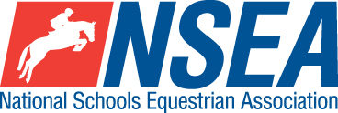
ARENA EVENTING (JUMPING WITH STYLE)
In outdoor all weather ‘Fred Arena’

Rules – NSEA General Rules plus ‘Additional Rules for Qualifiers 2020’

Class 1 Mini 70-75cm Team & Individual Qualifier
(Riders to be aged under 14 on 1st January 2020)
All team riders automatically count as individuals.

Class 2 Novice 80-85cm Team & Individual Qualifier
All team riders automatically count as individuals.

Class 3 Intermediate 90-95cm Team & Individual Qualifier.
All team riders automatically count as individuals

Class 4 Open 1m-1.05 Team & Individual Qualifier
All team riders automatically count as individuals

Class 5ab Advanced 1.10 Individual Qualifier a) horses and b) ponies
Please state whether you are riding a horse or pony section of the class, as the class will be split.

Entry Fee £21.00
Paramedic Medical Cover £4 per rider
Start Times will be available on the NSEA website 2 days before the competition www.nsea.org.uk

1st & 2nd placed team & 1-4th placed individuals will qualify for the 24th annual
NSEA National Schools Championships 2020
Addington Manor, October 2020
3rd -8th placed team & 5th-8th placed individuals will qualify for the
NSEA Championship Plate 2020
Keysoe 2020

ROSETTES FOR THIS SHOW VERY KINDLY SUPPORTED BY
BURGESS HILL GIRLS.
Brochures available in the café area

DRESSAGE
2 arenas in outdoor all weather ‘Paris’ Arena

Tests at Championship Qualifiers 2020 (Team & Individual) all in 20x40m arenas as follows..
Class 6 - Prelim = P 12 (2005) Warm up class, non qualifier. Individual only.

Class 7 - Prelim = P 13 (2006) Team & Individual Qualifier
Class 8 - Novice = N 24 (2010) Warm up class, non qualifier. Individual only.
Class 9 - Novice = N 28 (2008) Team & Individual Qualifier
Class 10 - Elementary = E 50 (2007) Individual Qualifier Only

Entry Fee £20 per test
Paramedic Medical Cover £4 per rider.

Teams
Teams shall be made up of 3 or 4 riders, best 3 scores to count. Up to two riders to compete in the prelim test and up to two riders in the novice test.
All team riders will automatically count for individual placings providing they are eligible (see NSEA ‘Additional rules)
The top 2 teams & 4 Individuals will qualify for the Championships

Rules – NSEA General Rules plus ‘Additional Rules for Qualifiers 2020’

Please note that Dressage tests at the Championships will be:
Championship Individual Tests 2020 all ridden in 20x60m arenas
Prelim 17A (2017), Novice 37A (2017) (Elementary 55 (2019), Medium 73 (2007)
Championship Team Tests 2020 all ridden in 20x40m arenas
Team Tests = Prelim 14 (2006) revised collectives 2016 (up to two riders), Novice 34 (2009) (up to two riders

Start Times will be available on the NSEA website 2 days before the competition www.nsea.org.uk

1st & 2nd placed team & 1-4th placed individuals will qualify for the 23rd annual
NSEA National Schools Championships 2020
Addington Manor, October 2020
3rd -8th placed team & 5th-8th placed individuals will qualify for the
NSEA Championship Plate 2020
Keysoe 2020
Applicable to both Arena Eventing (JWS) and Dressage Qualifiers

Disclaimer
Whilst all reasonable steps have been taken to ensure the health and safety of persons present at the event, Brendon Stud, Pyecombe accept no liability for any accident, loss or damage (save for death or personal injury) to any person, animal or property whatsoever, whether caused by their negligence, breach of contract or otherwise.

Your Responsibility
All persons attending the event must take all reasonable precautions to avoid and prevent accidents and must obey instructions given by the Organiser or by officials and stewards on its behalf.All competitors and those associated with their school are the responsibility of the Team Manager whilst at the competition

Child Protection & Safeguarding
If you have any concerns, please contact the NSEA on tel 07552 836032 / competition@nsea.org.uk to be put in contact with our designated Child Protection Officer. If you have immediate concerns, you can contact Childline tel 0800 1111 or NSPCC tel 0808 800 5000

TV & Photography
Please note that professional photographers will be present at the Qualifiers and there may also be TV cameras at the Championships. Please indicate on the entry form if you do not wish to appear in press coverage/ TV or photos taken by our official photographers.

General Information.
Please ensure that you do not muck out your horsebox onto the Car Park.
Horses/ponies are not allowed to be tied up outside horseboxes/trailers. Please take all litter home with your or use bins provided on showground. All dogs must be kept on leads at all times and please clear up any dog mess and place in bins provided.
Outside assistance will not be tolerated and could result in elimination. Callers are allowed in dressage tests.
NSEA affiliated competitors only may warm up and compete horses on the showground. Hardstanding car park. Café onsite open all day. Brendon Saddlery will be open all day – located in main warehouse in rear car park.

