standard_web_banner



**AT**

**BRENDON STUD, HARESDEAN LANE, PYECOMBE, WEST SUSSEX. BN45 7EG**

**PLEASE COME AND SUPPORT A GREAT CAUSE AND HAVE SOME FUN WITH YOUR PONIES AND HORSES.**

**SATURDAY 16TH NOVEMBER - ARENA EVENTING IN OUTDOOR PARIS ARENA, CLASSES FROM 70cm. UNAFFILIATED JUMPING IN OUTDOOR FRED ARENA WITH CLASSES STARTING AT 50cm.**

**SUNDAY 17TH NOVEMBER - ARENA EVENTING IN OUTDOOR PARIS ARENA, CLASSES FROM 80cm. INDOOR SCHOOL - FUN SHOWING AND DOG AGILITY & MINI X-POLES JUMPING CLASSES -**

**THESE CLASSES ARE ALL ABOUT THE KIDS HAVING FUN WITH THEIR PONIES.**

**HORSES/PONIES & RIDERS CAN DRESS UP ALL WEEKEND – ANYTHING SPOTTY OR SUPER HEROES GOES!**

**All we ask is correct hats and boots please in all classes.**

**TABLE TOP SALE IN THE OFFICE WITH LOTS OF EQUESTRIAN ITEMS DONATED BY SUPPLIERS –**

**ALL MONEY FROM THESE ITEMS WILL GO TO CHILDREN IN NEED.**

**CHILDRENS LUCKY DIP TOMBOLA STAND**

**GUESS HOW MANY SWEETS IN THE JAR COMPETITIONS.**

**ARENA EVENTING -**

**SATURDAY NOVEMBER 16TH 2019 - 9am START**

**Course will be run in the Paris Arena and will extend into the Paris Warm up Arena for some classes.**

**ENTER ONLINE AT WWW.BRENDONPYECOMBE.CO.UK**

At this show riders and ponies/horses can dress up in all classes for Children In Need – Theme is Superheroes this year but any fancy dress is acceptable and lots of spots! Normal competition wear is still acceptable as well. £2.00 from each entry fee will be donated to Children In Need. Please come and support us. Arena Eventing Classes are all pre-entry.

Pre-Entry closing date: Wednesday 13th November or before if full

**Class 1A - Arena Eventing Class – approx 70cm -** Riders aged 15 years & under on day of event.

**Sponsored by: CARL BUTTON BSM BRIGHTLIGHTS DRIVING SCHOOL**

**Class 1B – Arena Eventing Class– approx 70cm** – Riders aged 16 years and over on day of event.

**Sponsored by: TRUSLERS HORSES**

Approx 16 fences in course. Pre entry only. Water splash option available and only middle part of devils dyke to be jumped. **1st-10th qualify for SEEL Arena Eventing Championship held at Petley Wood in February 2020 and our own Championships February 29th and March 1st 2020. Prize for best fancy dress. 1st 10 gain points for Pyecombe Points League. 2020 Sunshine Tour Qualifier.**

**Entry Fee:** £22

**Class 2 - Arena Eventing Pairs Class** - Pre-entry only. **Entry Fee:** £28

**Sponsored by: CLARE CHAPMAN AND FAMILY**

Run as a rescue relay. 1st rider will jump approx 10 fences at approx 70cm, return to change over box to 2nd rider to complete course of approx 10 fences at 80cm. 1st rider must be in change over start box before 2nd rider starts. If 1st rider is eliminated other rider can complete both phases, if 2nd rider eliminated then pair is eliminated. Water splash option available and only middle part of devils dyke to be jumped.

**Class 3A - Arena Eventing Class– approx 80cm** – Riders aged 15 years & under on day of event.

**Sponsored by: LOVING PAWS**

**Class 3B - Arena Eventing Class– approx 80cm** – Riders aged 16 years and over on day of event.

**Sponsored by: BANFF BEAUTY - £20 Beauty Voucher to the winner of this section.**

Two sets of rosettes. Approx 20 fences in course. Pre-entry only. Water splash option available and only middle and last part of devils dyke to be jumped. **1st-10th qualify for SEEL Arena Eventing Championship held at Petley Wood in February 2020 and our own Championships February 29th and March 1st 2020. Prize for best fancy dress. 1st 10 gain points for Pyecombe Points League. 2020 Sunshine Tour Qualifier. Entry Fee:** £23

**Class 4 - Arena Eventing Class – approx 90cm Entry Fee:** £23

**Sponsored by** **KATE DORNEY (50 year old knacker (her words!) getting back to eventing!!**

Pre-entry only. Water splash option available and only middle and last part of devils dyke to be jumped.

**1st-10th qualify for SEEL Arena Eventing Championship held at Petley Wood in February 2020 and our own Championships February 29th and March 1st 2020. Prize for best fancy dress. 1st 10 gain points for Pyecombe Points League. 2020 Sunshine Tour Qualifier.**

**FANCY DRESS PRIZES -**

**AWARDED IN ALL ARENA EVENTING CLASSES AND JUMPING CLASSES ON SATURDAY & SUNDAY AT**

**JUDGES DISCRETION**

All classes will be run over a section of Show Jumps followed by a section of simulated cross-country and natural fences (some will be fixed & some will be knockdown fences).

The Cross-country section will be timed.

Winner will be the fastest time over the timed section. All classes will be run under Single Phase.

4 second penalty added for each refusal on non-timed part of the course.

10 seconds to be added for a knock down. 3 refusals in total – elimination.

Any riding deemed dangerous by judges/steward may incur elimination. Judges decision is final.

1st fall of rider - elimination. Fall of horse – elimination.

BE compliant XC kit must be worn - See Rules 5 & 6. Stop watches and Go Pro Cameras are not permitted.

**First Aid** - £4 per rider. All entries in advance so individual times can be given.

Rosettes 1st-10th in each class.

**Please check website from the Friday morning before the show for individual times:** [**www.brendonpyecombe.co.uk**](http://www.brendonpyecombe.co.uk)

**ARENA EVENTING RULES AND CONDITIONS OF ENTRY -   
Standard Brendon Stud Show Rules will apply and added rules for this show are:**.

1. Horses/ponies must compete at their allocated time slot.
2. No horse/pony under the age of four years may compete, and only horses/ponies competing in the show may be ridden on the show ground.
3. **HATS** All riders MUST wear correctly fitting approved protective headgear conforming to VG1, ASTM, PAS 015, SEI, or SNELL E2001, carrying the BSI Kite Mark, which includes retaining harness secured to the shell at more than two points and with no fixed peak. Must be worn and be correctly fastened **AT ALL TIMES** when mounted.
4. **HAIR** Riders must wear their hair no longer than shoulder length, neatly & firmly secured.
5. **BODY PROTECTORS MUST BE WORN.** Correct riding dress, including light coloured breeches or jodhpurs, must be worn. Cross country colours allowed.
6. **All entries are pre-entry. Once classes are full/times published on website, entries will not be refundable under any circumstances unless we can sell your entries. We will operate a waiting list.**

**HOW TO ENTER: All entries must be made online please at** [**www.brendonpyecombe.co.uk**](http://www.brendonpyecombe.co.uk)**.**

**80cm and 90cm Arena Eventing Classes will all be qualifiers for SEEL Arena Eventing Championship to be held at Coombelands in February 2019. More details available in secretary’s on the day.**

**All classes except pairs will qualify for our Pyecombe Points League and Championship show on March 2 & 3 2019…more info to follow.**

**SPIDGE PHOTOGRAPHY**

In attendance at this show. On site printing services. Donation to Children In Need for all photos sold this weekend. [www.spidge.co.uk](http://www.spidge.co.uk)

|  |
| --- |
| **C:\Users\Caraleen\AppData\Local\Microsoft\Windows\Temporary Internet Files\Content.MSO\CCC69E06.tmp** **Accountancy & Business Matters Ltd.** **Certified Public Accountants & Tax Consultancy**  The Barn, Golden Square, Henfield, BN5 9DP **Tel: 01273 495665 or 01273 491112** email: [laura@abmatters.com](mailto:laura@aandbmatters.com)  **Smp Ponies**  Pony Producers  Sales/backing/schooling/sales livery  Small pony specialists. From lead rein to competition ponies. Based Hampshire GU336HU  Follow us on facebook: SmpPonies 07939 595119 |

|  |
| --- |
| **REDLANDS TRANSPORT** For all your equine transports needs!  All drivers hold certificate of competence type two. Animal transporter type two authorisation.  Fully insured hire and reward insurance, care and custody and equine breakdown cover. 07845 738681 / 07712 621881  Email: Katya Visser at k.visser.16@icloud.com |
| TRUSLERS HORSES  Importers of top class showjumpers, eventers and dressage youngstock  For regular updates follow us on Facebook. Based near Hickstead, West Sussex. 07765052495 |
|  |
|  |
|  |

**BELLA ROSE EQUESTRIAN CLOTHING RANGE**

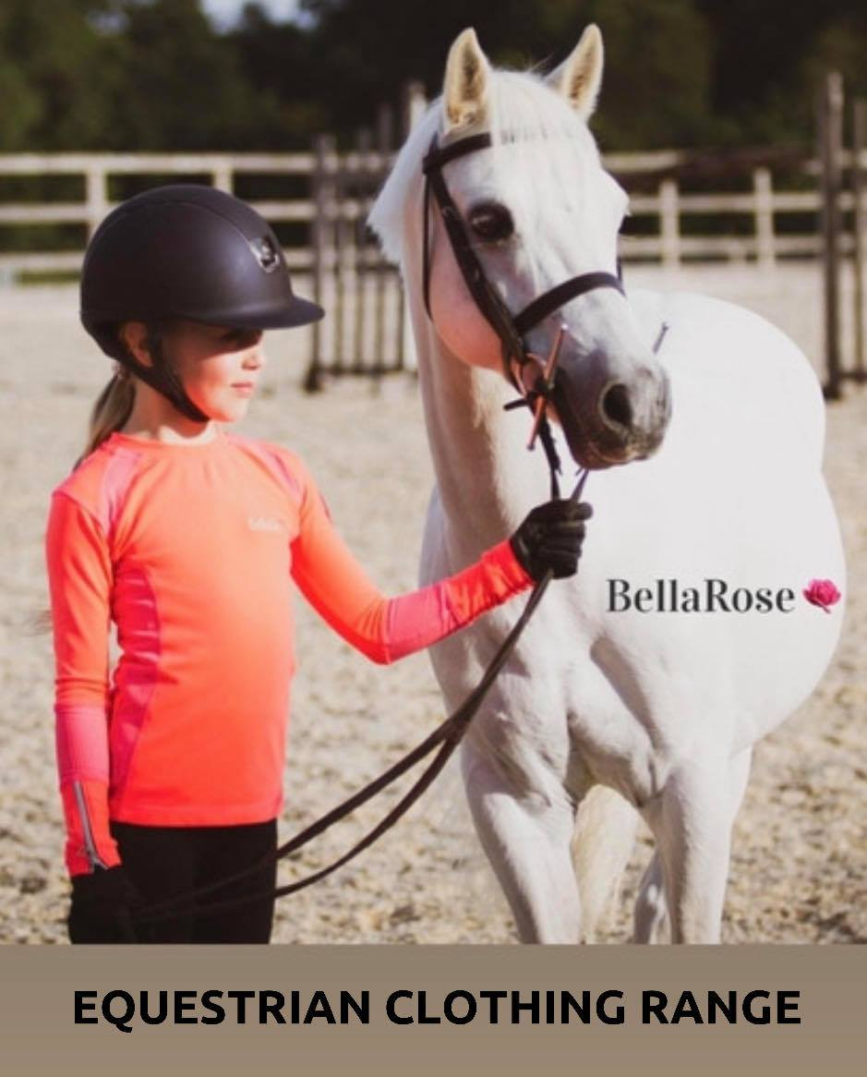

**THE SWEET BROTHERS**

**Sweet & Donut Cart available to hire for all wedding, birthday and parties**

**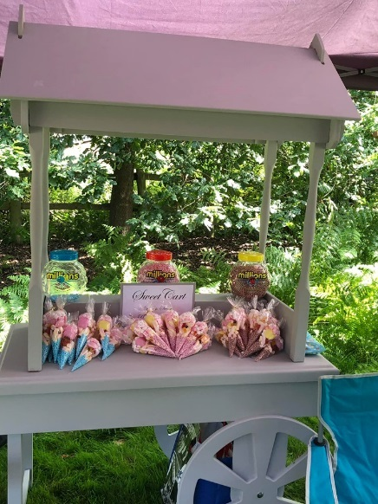**

[**https://www.facebook.com/thesweetbrothers1/**](https://www.facebook.com/thesweetbrothers1/)

**Tel: 07748 185533 Based in East Sussex.UNAFFILIATED JUMPING – 9.00am**

**‘FRED OUTDOOR’ ARENA - SATURDAY NOVEMBER 16TH**

**BRITISH SHOWJUMPING COURSEBUILDER/JUDGE**

At this show riders and ponies/horses can dress up in all classes for Children In Need – Theme is Superheroes this year but any fancy dress is acceptable and lots of spots! Normal competition wear is still acceptable as well. £1.50 from each entry fee will be donated to Children In Need. Please come and support us. Due to limited daylight hours we strongly recommend pre-entry on website to guarantee your entry. We will accept entries on the day if space allows.

lass 5: CLEAR ROUND - Sponsored by: CAROLINE BAKER EQUINE COACH

Approx 50cm. £7, collect ticket from secretary. Rosettes to all clears. Limited to 20 tickets, this clear round will only run for approx 30 minutes.

Class 6: 50cm OPEN. Entry Fee £12

Sponsored by: MANE MOVE TRANSPORT & DARREN WOODS

Open to all horses and ponies. Single phase. All clears will share =1st and receive a first

rosette and a medal.

Class 7: 60cm OPEN. Entry Fee £12

Sponsored by: THE SWEET BROTHERS

Open to all horses and ponies. Single phase. Eligible double clears qualify

for Cricklands 10 & Under 2’0. Rosette, Sash, Trophy and Medal to winner, Rosettes and

medals to 2nd and 3rd, Rosettes 4th-6th and all double clears

Class 8: 70cm OPEN. Entry Fee £12

Sponsored by: PINE RIDGE EQUESTRIAN CENTRE

Open to all horses and ponies. Single phase. Double clears qualify for

Cricklands 2’3. . Rosette, Sash, Trophy and Medal to winner, Rosettes and

medals to 2nd and 3rd, Rosettes 4th-6th and all double clears.

Class 9: 80cm OPEN. Entry Fee £12

Sponsored by: SMP PONIES

Open to all horses and ponies. Single phase. Double clears qualify for

Cricklands 2’6. Rosette, Sash, Trophy and Medal to winner, Rosettes and

medals to 2nd and 3rd, Rosettes 4th-6th and all double clears.

Class 10: 90cm OPEN. Entry Fee £12

Sponsored by: SYNOVIUM HORSE HEALTH

Open to all horses and ponies. Single phase. Double clears qualify for

Cricklands 2’9. Rosette, Sash, Trophy and Medal to winner, Rosettes and

medals to 2nd and 3rd, Rosettes 4th-6th and all double clears.

Refusal Faults: 1st and 2nd refusal – 4 faults each. 3rd refusal =elimination.

Fall of horse or rider: Judge will advise if allowed to remount and finish course but will incur elimination.

All entries on the day. Café and saddlery shop open all day on show days.

£4 paramedic charge per rider.

Arena layout for this shows will be:

Fred arena warm up arena - Car Park end of Fred arena.

Fred arena will be slightly smaller than normal events.

Far end of Fred area: Warm up area for Paris Arena will be the normal far end of Fred arena warm up area.

COLLECT CARD FROM SECRETARY FOR FOLLOWING:

CRICKLANDS QUALIFIERS: - double clears – [www.cricklands.com](http://www.cricklands.com)

    

**FANCY DRESS PRIZES -**

**BEST FANCY DRESS IN ARENA EVENTING CLASSES AND JUMPING**

**CLASSES ON SATURDAY**

|  |
| --- |
| **UK ROSETTES**  Todays Rosettes Suppliers - Sashes – Rosettes -  Ribbons for all equestrian and other events. Bespoke orders welcome**.**  **Tel:** 01883 626644 **Mobile:** 07904 155140 [**www.ukrosettes.co.uk**](http://www.ukrosettes.co.uk) |
| Synovium Horse Health  A brand you can trust to look after your horse!  Website: [www.synovium.co.uk](https://l.facebook.com/l.php?u=http%3A%2F%2Fwww.synovium.co.uk%2F%3Ffbclid%3DIwAR3yamXjb5EKMB64JLnhW9u3zcJ-asnaXwkiOz8CHzPxBzNLvowsDUQh7Lg&h=AT1z5SJTVfP_XoDEapo7ssqayqCfgI8vKp66Lrp2jp5L2arsPTaFFEO-eVMDAXu5zTnfrbRkyjpcZTM_wmUxG9_1IIEDFcJrIjxQYGaunZeSySwVWI0Kyv4ezGfOsql7QiUDvyLPdJRa8rELPiib5Jd_SaPp1VogFk8-WsElsG35mjom2G3KInHUx6hzM5RaL1oXbWfpbTKX1Zh-NVrprs0OjCPNdsiYNCttcXW-petiqrfZbP1lvvDZ4Qk0jk5c31FIfGGtBlG_coWZvlRMhIBcFq9rlth0zIaxGVsN7OU0izBi-o6iiP3Mlx50nhMOgF-O35wOrY0FC2vbK9bkNjTlGAb-bV3XHcRUhDDRRiNa-mrwNmU0QCdjEpu_0ytU3PTtXIftr9JnahF8iz_54Ra4Sad_t64sg3D4hhaIyhH8FEezlNGVq7ZpqYJbe3X19KOA3r2vv0Ht9MRjWfWvFw__9iXGmvdUs85fNbz7pLcq62VaTc04dYue8chh4quiwsjdq6GYD9fmnv_tGiEx6e-z7VgPbXGDG4KyHK_9oDV3iglJ850IIGFvL5_VorXweR5PlkS8gpAXN7vW7XA9Fy2pTG1iLoDvFUfs5oqCoIBcyG-Gnujc75tHt2rrKmdCrj21p70jRsJ-riU7uKpMh90VSFK0pQJdjr0EKI0xAEzTCmCtLDjaJqGiQmgKwGfBaJ6bkVvzl42M-cOgq344gEakOIvcVDUTTKOJXwVB9DvbHMJYBwXB1ROvRh5PK0LhUOWTtcbs-En0ERdbu_f7y_fw5qneUhRAfMph6OF5_9rIJoU1s1xYHvjw7Iba-mqnnCQsko8) |
| **NEW STREET GARAGE**  New Street Garage is a family run business that has been established in Horsham, West Sussex for over 19 years. We are conveniently situated within a 5 minute walk from Horsham town centre which makes it easy for dropping your car off. We have a team of fully qualified technicians with a vast amount of knowledge in the motor trade. MOT’S AVAILABLE  7 New Street,Horsham, West Sussex. RH13 5DT **T: 01403 274060 E:** [**info@newstreetgarage.co.uk**](mailto:info@newstreetgarage.co.uk) |
| **DARREN WOODS**  FREELANCE Equine Instructor covering Sussex area.  Dressage, showjumping, eventing disciplines  **Tel: 07879 417759 Email:** [dazza\_hick@hotmail.com](mailto:dazza_hick@hotmail.com)  MANE MOVE EQUINE TRANSPORT  We offer Horse Transport from short distance yard moves to long distance transport throughout the whole of the UK.  Fully insured, DEFRA approved. Based in Bromley, Kent.  **Mobile:** 07782 385131 Email: andreazxzxzx2003@yahoo.co.uk  **Join us on facebook: Mane Move Equine Transport** |
|  |
| PINE RIDGE EQUESTRIAN CENTRE  Riding lessons, Coaching, Livery, Pony Club all catered for.  Breaking & Schooling Livery. Council approved riding school & Pony Club centre. Onsite dressage and showjumping clinics.  **Pound Lane, Knockholt. TN14 7NE**  **Mobile:** 01959 533161 Email: [pineridgers@hotmail.com](mailto:pineridgers@hotmail.com)  [www.pineridgers.com](http://www.pineridgers.com) |

****

**   MANY THANKS TO THE SPONSORS WHO HAVE KINDLY SPONSORED ROSETTES, SASHES, TROPHIES & LUCKY DIP PRIZES**

     

|  |
| --- |
| **MANY THANKS TO THE FOLLOWING PRIVATE SPONSORS**  FOR YOUR SUPPORT:  CLARE CHAPMAN & FAMILY  LIAM WILLIAMS of L S EQUESTRIAN  ROB WHITAKER & FAMILY  MS EMMA COOK  PIPPA WOODALL  WENDY NEATH  KATE DORNEY  SAMANTHA OSBORN &  TEAM SUFFIELD  LISA VILLENEUVE  AND BIG THANK YOU TO OUR ANONYMOUS SPONSORS AND COMPANIES THAT CONTRIBUTE  TOWARDS THE TABLE TOP SALE,  LUCKY DIPS AND CAKE SALES. |

**ARENA EVENTING -**

**SUNDAY NOVEMBER 17TH 2019 - 9am START**

**Course will be run in the Paris Arena and will extend into the Paris Warm up Arena for some classes.**

**ENTER ONLINE AT WWW.BRENDONPYECOMBE.CO.UK**

At this show riders and ponies/horses can dress up in all classes for Children In Need – Theme is Superheroes this year but any fancy dress is acceptable and lots of spots! Normal competition wear is still acceptable as well. £2.00 from each entry fee will be donated to Children In Need. Please come and support us. Arena Eventing Classes are all pre-entry.

Pre-Entry closing date: Wednesday 13th November or before if full

**Class 11A - Arena Eventing Class – approx 70cm -** Riders aged 15 years & under on day of event.

**Sponsored by LIV WATTS EQUINE SERVICES**

**Class 11B – Arena Eventing Class– approx 70cm** – Riders aged 16 years and over on day of event.

**Sponsored by: PINE RIDGE EQUESTRIAN CENTRE**

Approx 16 fences in course. Pre entry only. Water splash option available and only middle part of devils dyke to be jumped. **1st-10th qualify for SEEL Arena Eventing Championship held at Petley Wood in February 2020 and our own Championships February 29th and March 1st 2020. Prize for best fancy dress. 1st 10 gain points for Pyecombe Points League. 2020 Sunshine Tour Qualifier.**

**Entry Fee:** £22

**Class 12A - Arena Eventing Class– approx 80cm** – Riders aged 15 years & under on day of event.

**Sponsored by REDLANDS TRANSPORT**

**Class 12B - Arena Eventing Class– approx 80cm** – Riders aged 16 years and over on day of event.

**Sponsored by DEVULDER EQUESTRIAN**

Two sets of rosettes. Approx 20 fences in course. Pre-entry only. Water splash option available and only middle and last part of devils dyke to be jumped. **1st-10th qualify for SEEL Arena Eventing Championship held at Petley Wood in February 2020 and our own Championships February 29th and March 1st 2020. Prize for best fancy dress. 1st 10 gain points for Pyecombe Points League. 2020 Sunshine Tour Qualifier. Entry Fee:** £23

**Class 13 - Arena Eventing Class – approx 90cm Entry Fee:** £23

**Sponsored by KATE DORNEY (50 year old knacker (her words!) getting back to eventing!!**

Pre-entry only. Water splash option available and only middle and last part of devils dyke to be jumped.

**1st-10th qualify for SEEL Arena Eventing Championship held at Petley Wood in February 2020 and our own Championships February 29th and March 1st 2020. Prize for best fancy dress. 1st 10 gain points for Pyecombe Points League. 2020 Sunshine Tour Qualifier.**

**Class 14 - Arena Eventing Class – approx 1m Entry Fee:** £23

**Sponsored by SYNOVIUM HORSE HEALTH**

Pre-entry only. Water splash option available and only middle and last part of devils dyke to be jumped.

**1st-10th qualify for SEEL Arena Eventing Championship held at Petley Wood in February 2020 and our own Championships February 29th and March 1st 2020. Prize for best fancy dress. 1st 10 gain points for Pyecombe Points League. 2020 Sunshine Tour Qualifier.**



**Loving Paws Pet Services**are based in Lingfield Surrey and run by Sandra and her family with over 40 year of experience and involvement with dogs and other animals.

We are offering a friendly and tailored service to suit you and your pets needs, always treating them as our own.

  We walk all of our dogs on a private 25 acre estate and we also have 5 acres of private woodland, where even on the hottest day of the year it stays cool as it is sheltered and in the winter doesn't get very wet\muddy.  You can be rest assured that your dog won’t meet any others not known to us on their walk.

​We will discuss your pets preferences at our initial meeting to make sure they get the best from their walk/stay with us.  We are fully insured.

#### Email:[info@lovingpaws.co.uk](mailto:info@lovingpaws.co.uk?subject=Thank%20you%20for%20enquiring%20with%20Loving%20Paws) Telephone: [07753 242977](tel:07753242977) [www.lovingpaws.co.uk](http://www.lovingpaws.co.uk)

#### DEVULDER EQUESTRIAN

Devulder Equestrian is an equestrian teaching, training and problem solving business

that can help you improve all aspects of your riding and relationship.

Based in Surrey and regularly running clinics in Sussex and Surrey at competition venues.

**Email:** [**devulder\_equestrian@hotmail.com**](mailto:devulder_equestrian@hotmail.com)

**Tel: 07753 242977**

Find us on facebook to keep updated with news and events  
 <https://www.facebook.com/devulderequestrian/>

 **SUSSEX RUG SERVICES**

Equine and Outdoor Laundry Repair Service – Rugs, Jackets, Coats,

Gazebos, Caravan Awnings.

All work done ‘in house’, Repair only service available. Delivery/collection service.

**01444 471650 / 07510 600412** [**www.sussexrugservices.co.uk**](http://www.sussexrugservices.co.uk)

**SUNDAY NOVEMBER 17TH 2019**

ALL CLASSES TO BE HELD IN INDOOR ARENA 9.30am Start

At this show riders and ponies/horses can dress up in all classes for Children In Need – Theme is Superheroes this year but any fancy dress is acceptable and lots of spots! Normal competition wear is still acceptable as well. £2 from each entry fee will be donated to Children In Need. Please come and support us. Entries taken on the day but helpful if you can pre-enter online at [www.brendonpyecombe.co.uk](http://www.brendonpyecombe.co.uk) to help with timings on the day. Thank you

Class 15: **Marvellous Mare** . Sponsored by: FITTER RIDER

Any sized mare, open to all ridden **non lead rein**. Winner qualifies for Championship after Class 22

Class 16: **Marvellous Mare** Sponsored by: ACCOUNTANCY & BUSINESS MATTERS LTD

Any sized mare, open to **all lead reins & in hand**. Winner qualifies for Championship after class 22

Class 17: **Gorgeous Gelding** Sponsored by: WENDY NEATH

Any sized gelding, open to all ridden **non lead rein.** Winner qualifies for Championship after Class 22

Class 18: **Gorgeous Gelding** Sponsored by: THE SWEET BROTHERS

Any sized gelding, open to all lead reins & in hand. Winner qualifies for Championship after Class 22

Class 19: **Pony Club Pony** – **(approx 11.30am)** Sponsored by: PIPPA WOODALL & JILL WOOD

Small x-poles jump included and bending cones. Will be split into lead rein & non lead rein

if sufficient entries. Winner qualifies for Championship after class 22.

Class 20: **The Pony The Judge Would Like To Take Home**

Sponsored by: BELLA ROSE EQUESTRIAN & SUSSEX RUG SERVICES

Open to all. Will be split into lead rein / in hand and non lead rein if sufficient entries. Winner qualifies

for Championship after Class 22.

Class 21: **Best Rider** – **Non Lead Rein (approx 1pm)** Sponsored by: LS EQUESTRIAN

Open to all ages. May be split if sufficient entries. Cantering in individual show optional.

Winner qualifies for Championship after Class 22.

Class 22: **Best Rider** Sponsored by: LOVING PAWS

Lead Rein Only. Judged on rider ability. Winner qualifies for Championship after Class 22.

**CHAMPIONSHIP** – Open to all winners of classes 15-22, no entry fee payable. Rosettes to all.

Sponsored by: TEAM SUFFIELD

Class 23: **Bottom Hole X-Poles Clear Round.** Sponsored by: NEW STREET GARAGE

No spreads. Can be led/assisted. Ponies can do this class with mulitple riders. Ponies must

have lead reins attached to nosebands. All competitors will receive a rosette in this class.

Class 24: **Pony and Paws Fun Class** – Sponsored by: NOSE 2 TAILS PETS & DOGTAILS.

Open to all children with a dog. Pony and rider to jump first half of small x-pole jumps and

then dismount and lead dog over rest of course. Dogs can have different child to run with if they

want. (adults can assist younger children!). Treat prize to the dog with most coloured spots.

Class will be split into 8 years & under and 9 years and over.

Class 25: **X-Poles Jumping** – Sponsored by: IG EQUINE BOUTIQUE

Approx 30cm-40cm. No spreads. Can be led/assisted. Ponies can do this class with two

different riders. Ponies must have lead reins attached to nosebands. All double clears will

share equal 1st and receive medal. All competitors will receive a rosette in this class.

Rosettes, Trophies, Medal & Sashes in all classes.

Rosettes to all competitors in all classes 15-22

Entry Fees for all classes: £10.00 except Clear Round £6.00 payable at secretary’s.

No group cantering in any showing classes. Cantering in individual show optional.

Lead Rein classes are suitable for disabled competitors who are most welcome.

If insufficient entries some classes may be amalgamated. General Brendon Pyecombe Show Rules Apply.

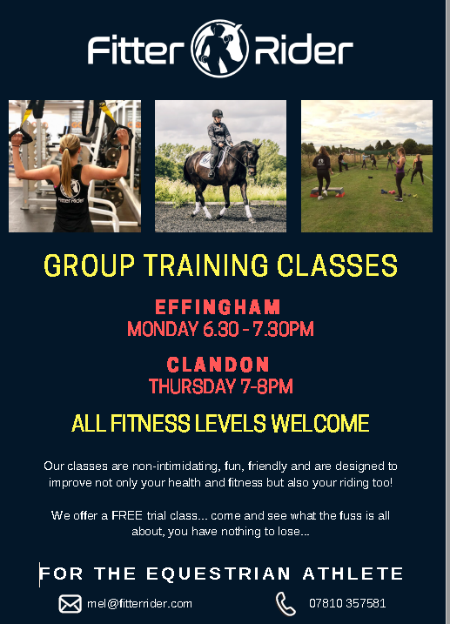





Professional Dog Groomers - All our basic,and full groom packages include:

A full health check, bath, blow dry, ear clean, nail trim, blueberry facial and cologne. **Based in Crawley.**

**Contact Vicky Raine (City & Guilds qualified groomer)**

**01293 278775 Email:** [**info@dogtailsgrooming.co.uk**](mailto:info@dogtailsgrooming.co.uk)

[**www.dogtailsgrooming.co.uk**](http://www.dogtailsgrooming.co.uk)

**    **

BRENDON SADDLERY

**Visit our onsite saddlery - located through car park in main barn.**

**Extensive range of all pony, horse & rider equipment instore and on line.**

**HORSE & RIDER COMPETITION WEAR**

**Ariat, Kingsland, Tech Stirrups, Montar, Cavallo, Harcour**

**Noble Outfitters, Freejump, Schockemohle, GPA,**

**Veredus, Equiline, Prestige, Whitaker, Stephens, Le Mieux, Cavalliero, Horseware, HKM, Stubben, Mark Todd, KEP,**

**BR Horse Boots, QHP Clothing, Jumpers Horse Line, Charles Owen, Horse Health, Gatehouse, Omega,**

**Horse First, Equine America, Lincoln, Net-tex, KM Elite.**

**Superb selection of Show Shirts, Jackets and Breeches**

**Large selection of long and short riding boots in stock.**

**Feed & Shavings** – Excellent quality white shavings.

Dodson & Horrell, Pure Feed, Omega Equine,

Baileys, Top Spec, Horsehage, Pegasus, Mollichaff, Dengie

**Tel: 01273 845545 OR BUY ON LINE:** [**www.brendonsaddlery.co.uk**](http://www.brendonsaddlery.co.uk)

