AT
BRENDON STUD, HARESDEAN LANE, PYECOMBE, WEST SUSSEX. BN45 7EG

PLEASE COME AND SUPPORT A GREAT CAUSE AND HAVE SOME FUN WITH YOUR PONIES AND HORSES.

SATURDAY 20^{H} NOVEMBER 2021
ARENA EVENTING IN PARIS ARENA 70cm – 90cm including PAIRS CLASS. UNAFFILIATED JUMPING IN FRED ARENA WITH 50cm – 90cm.

SUNDAY 21ST NOVEMBER 2021
ARENA EVENTING IN PARIS ARENA 70cm-1m. INDOOR SCHOOL - FUN SHOWING, PONY & PAWS CLASS & MINI X-POLES JUMPING.
THESE CLASSES ARE ALL ABOUT THE KIDS HAVING FUN WITH THEIR PONIES.

HORSES/PONIES & RIDERS CAN DRESS UP ALL WEEKEND – ANYTHING SPOTTY OR SUPER HEROES GOES!
All we ask is correct hats and boots please in all classes.

TABLE TOP SALE IN THE OFFICE–
ALL MONEY WILL GO TO CHILDREN IN NEED.

We don’t do Repairs….We don’t sell spares…. WE ONLY M.O.T.
Cars and motorbikes. Phone now to book your MOT.
Highly recommended by Brendon Stud
Unit 7, Teknol House, Victoria Road, Burgess Hill.
01444 254000

Whether you need a complete redesign of your entire house or just a pair of curtains, we will provide you with help and advice.
www.tracycottrelldesigns.co.uk 01344 624222 / 07831 431406

“Team Phoenix is run by Carl Belson (BECC & BSCC Level 3 & Excel Coach) and Luke Thompson (professional showjumper and eventer) who (combined) have over 40 years of experience working in the equine industry.

The Team provides private equestrian coaching, training, residential camps, and competition planning and support for all levels of riders from grassroots up to FEI. They can also offer competition preparation, schooling/backing livery services, schooling services (at your own yard), clipping and competition preparation and often have quality youngsters in for producing and sale.

For further information contact: phoenixequestrian@outlook.com or call Carl on 07867 499 499. To find out about what the Team is up to, why not follow us on Facebook @PhoenixEquestrianEquine

ARENA EVENTING -
SATURDAY NOVEMBER 20^{H} 2021 - 9am START
Course will be run in the Paris Arena and will extend into the Paris Warm up Arena for some classes.
ENTER ONLINE AT WWW.BRENDONPYECOMBE.CO.UK
At this show riders and ponies/horses can dress up in all classes for Children In Need – Theme is Superheroes this year but any fancy dress is acceptable and lots of spots! Normal competition wear is still acceptable as well. £2.00 from each entry fee will be donated to Children In Need. Please come and support us. Arena Eventing Classes are all pre-entry.
Pre-Entry closing date: Wednesday 17th November or before if full

Class 1A - Arena Eventing Class – approx 70cm - Riders aged 15 years & under on day of event.
Sponsored by: MR MOT
Class 1B – Arena Eventing Class– approx 70cm – Riders aged 16 years and over on day of event.
Sponsored by: EQUIPASSION UK
Approx 16 fences in course. Pre entry only. Water splash option available and only middle part of devils dyke to be jumped. 1st-10th qualify our own Championships in February 2022. Prize for best fancy dress. 1st 10 gain points for Pyecombe Points League. 2022 Sunshine Tour Qualifier.
Entry Fee: £25

Class 2 - Arena Eventing Pairs Class - Pre-entry only. Entry Fee: £28
Sponsored by: A P EQUESTRIAN
Run as a rescue relay. 1st rider will jump approx 10 fences at approx 70cm, return to change over box to 2nd rider to complete course of approx 10 fences at 80cm. 1st rider must be in change over start box before 2nd rider starts. If 1st rider is eliminated other rider can complete both phases, if 2nd rider eliminated then pair is eliminated. Water splash option available and only middle part of devils dyke to be jumped.

Class 3A - Arena Eventing Class– approx 80cm – Riders aged 15 years & under on day of event.
Sponsored by: T J CLIPPING
Class 3B - Arena Eventing Class– approx 80cm – Riders aged 16 years and over on day of event.
Sponsored by: TEAM PHOENIX EQUESTRIAN
Two sets of rosettes. Approx 20 fences in course. Pre-entry only. Water splash option available and only middle and last part of devils dyke to be jumped. 1st-10th qualify for SEEL Arena Eventing Championship held at Coomblelands in February 2022 and our own Championships in Feb/March 2022. Prize for best fancy dress. 1st 10 gain points for Pyecombe Points League. 2022 Sunshine Tour Qualifier. BE Arena Eventing Qualifier. Entry Fee: £25

Class 4 - Arena Eventing Class – approx 90cm Entry Fee: £25
Sponsored by: JILL TASKER & ‘ZAC’
Pre-entry only. Water splash option available and only middle and last part of devils dyke to be jumped.
1st-10th qualify for SEEL Arena Eventing Championship held at Coomblelands in February 2022 and our own Championships in Feb/March 2022. Prize for best fancy dress. 1st 10 gain points for Pyecombe Points League. 2022 Sunshine Tour Qualifier. BE Arena Eventing Qualifier.

FANCY DRESS PRIZES -
AWARDED IN ALL ARENA EVENTING CLASSES AND JUMPING CLASSES ON SATURDAY & SUNDAY AT
JUDGES DISCRETION

All classes will be run over a section of Show Jumps followed by a section of simulated cross-country and natural fences (some will be fixed & some will be knockdown fences).
The Cross-country section will be timed.
Winner will be the fastest time over the timed section. All classes will be run under Single Phase.
4 second penalty added for each refusal on non-timed part of the course.
10 seconds to be added for a knock down. 3 refusals in total – elimination.
Any riding deemed dangerous by judges/steward may incur elimination. Judges decision is final.
1st fall of rider - elimination. Fall of horse – elimination.
BE compliant XC kit must be worn - See Rules 5 & 6. Stop watches and Go Pro Cameras are not permitted.
First Aid - £5 per rider. All entries in advance so individual times can be given.
Rosettes 1st-10th in each class.

Please check website from the Friday morning before the show for individual times: www.brendonpyecombe.co.uk

ARENA EVENTING RULES AND CONDITIONS OF ENTRY -
Standard Brendon Stud Show Rules will apply and added rules for this show are:.
- Horses/ponies must compete at their allocated time slot.
- No horse/pony under the age of four years may compete, and only horses/ponies competing in the show may be ridden on the show ground.
- HATS All riders MUST wear correctly fitting approved protective headgear conforming to VG1, ASTM, PAS 015, SEI, or SNELL E2001, carrying the BSI Kite Mark, which includes retaining harness secured to the shell at more than two points and with no fixed peak. Must be worn and be correctly fastened AT ALL TIMES when mounted.
- HAIR Riders must wear their hair no longer than shoulder length, neatly & firmly secured.
- BODY PROTECTORS MUST BE WORN. Correct riding dress, including light coloured breeches or jodhpurs, must be worn. Cross country colours allowed.
- All entries are pre-entry. Once classes are full/times published on website, entries will not be refundable under any circumstances unless we can sell your entries. We will operate a waiting list.
HOW TO ENTER: All entries must be made online please at www.brendonpyecombe.co.uk.

80cm and 90cm Arena Eventing Classes will all be qualifiers for SEEL Arena Eventing Championship to be held at Coombelands in February 2022. More details available in secretary’s on the day.
All classes except pairs will qualify for our Pyecombe Points League and Championship show in February/March 2022…more info to follow.

SPIDGE PHOTOGRAPHY
In attendance at this show. On site printing services. Donation to Children In Need for all photos sold this weekend. www.spidge.co.uk

T J CLIPPING SERVICES
For all your clipping needs. Based in Sussex.
Experienced with nervous horses.
Call Terisa on 07756 549782

FANCY DRESS PRIZES -
BEST FANCY DRESS IN ARENA EVENTING CLASSES AND JUMPING
CLASSES ON SATURDAY

UK ROSETTES
Todays Rosettes Suppliers - Sashes – Rosettes -
Ribbons for all equestrian and other events. Bespoke orders welcome.
Tel: 01883 626644 Mobile: 07904 155140 www.ukrosettes.co.uk

NEW STREET GARAGE
New Street Garage is a family run business that has been established in Horsham, West Sussex for over 19 years. We are conveniently situated within a 5 minute walk from Horsham town centre which makes it easy for dropping your car off. We have a team of fully qualified technicians with a vast amount of knowledge in the motor trade. MOT’S AVAILABLE
7 New Street,Horsham, West Sussex. RH13 5DT
T: 01403 274060 E: info@newstreetgarage.co.uk

DARREN WOODS
FREELANCE Equine Instructor covering Sussex area.
Dressage, showjumping, eventing disciplines
Tel: 07879 417759 Email: dazza_hick@hotmail.com

THE EQUI-FUN CLUB
Equi-Fun Club is a small friendly club for all riders.
Regular events run at Plumpton College include unaffiliated dressage, jumping and showing events.
Join us on facebook for all latest events.
http://www.equi-fun.co.uk/

UNAFFILIATED JUMPING – 9.00am
‘FRED OUTDOOR’ ARENA - SATURDAY NOVEMBER 20TH
BRITISH SHOWJUMPING COURSEBUILDER/JUDGE

At this show riders and ponies/horses can dress up in all classes for Children In Need – Theme is Superheroes this year but any fancy dress is acceptable and lots of spots! Normal competition wear is still acceptable as well. £1.50 from each entry fee will be donated to Children In Need. Please come and support us. Due to limited daylight hours we strongly recommend pre-entry on website to guarantee your entry. We will accept entries on the day if space allows.

Class 5: CLEAR ROUND - Entry Fee £7
Sponsored by: EQUNE AMERICA AND BELLA ROSE EQUESTRIAN
Approx 50cm. Rosettes to all clears.

Class 6: 50cm OPEN. Entry Fee £13
Sponsored by: CHRISTINE McCREA AND FAMLY.
Open to all horses and ponies. Single phase. All clears will share =1st and receive a first
rosette and a medal.

Class 7: 60cm OPEN. Entry Fee £14
Sponsored by: TEIGAN McNAMARA SHOWJUMPING
Open to all horses and ponies. Single phase. Cricklands and Sunshine Tour Qualifier. Rosette, Sash, Trophy and Medal to winner, Rosettes and medals to 2nd and 3rd, Rosettes
4th-6th and all double clears. Prize money £15 per placing per 10 starters.

Class 8: 70cm OPEN. Entry Fee £14
Sponsored by: GW EQUINE
Open to all horses and ponies. Single phase. Cricklands and Sunshine Tour Qualifier. Rosette, Sash, Trophy and Medal to winner, Rosettes and medals to 2nd and 3rd, Rosettes
4th-6th and all double clears. Prize money £15 per placing per 10 starters.

Class 9: 80cm OPEN. Entry Fee £14
Sponsored by: ACCUSTRIDE
Open to all horses and ponies. Single phase. Cricklands and Sunshine Tour Qualifier. Rosette, Sash, Trophy and Medal to winner, Rosettes and medals to 2nd and 3rd, Rosettes
4th-6th and all double clears. Prize money £15 per placing per 10 starters.

Class 10: 90cm OPEN. Entry Fee £14
Sponsored by: JILL TASKER & ‘ZIGGY’.
Open to all horses and ponies. Single phase. Cricklands and Sunshine Tour Qualifier. Rosette, Sash, Trophy and Medal to winner, Rosettes and medals to 2nd and 3rd, Rosettes
4th-6th and all double clears. Prize money £15 per placing per 10 starters.

Refusal Faults: 1st and 2nd refusal – 4 faults each. 3rd refusal =elimination.
Fall of horse or rider: Judge will advise if allowed to remount and finish course but will
incur elimination.

All entries on the day. Café and saddlery shop open all day on show days.
£5 paramedic charge per rider.

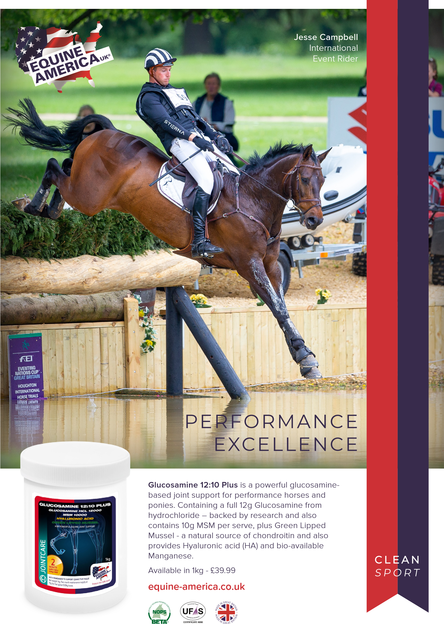

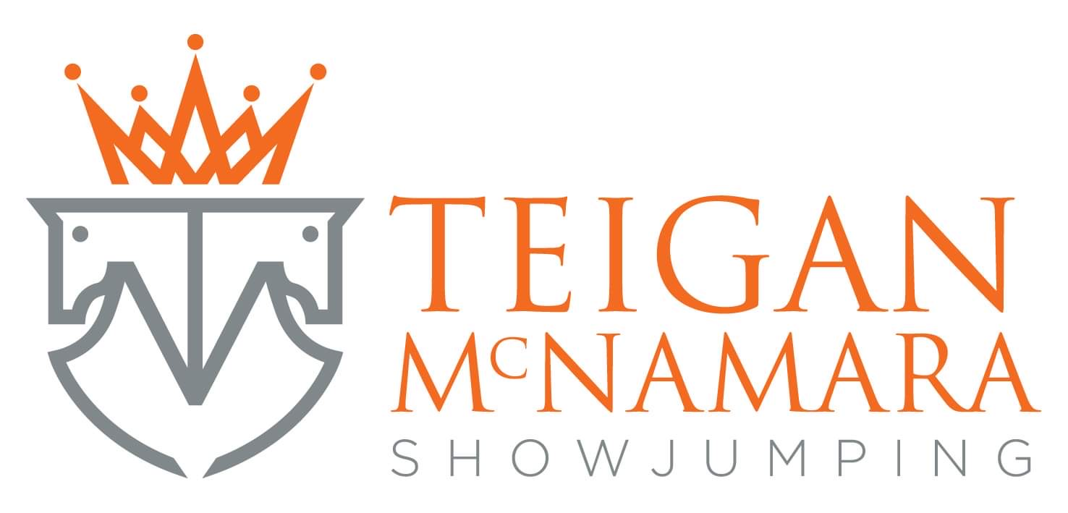
ARENA EVENTING -
SUNDAY NOVEMBER 21st 2021 - 9am START
Course will be run in the Paris Arena and will extend into the Paris Warm up Arena for some classes.
ENTER ONLINE AT WWW.BRENDONPYECOMBE.CO.UK

At this show riders and ponies/horses can dress up in all classes for Children In Need – Theme is Superheroes this year but any fancy dress is acceptable and lots of spots! Normal competition wear is still acceptable as well. £2.00 from each entry fee will be donated to Children In Need. Please come and support us. Arena Eventing Classes are all pre-entry.
Pre-Entry closing date: Wednesday 17th November or before if full

Class 11A - Arena Eventing Class – approx 70cm
Riders aged 15 years & under on day of event. Sponsored by: Mates Rates Transport
Class 11B – Arena Eventing Class– approx 70cm
Riders aged 16 years and over on day of event. Sponsored by: SportHorsesAuctions.com
Approx 16 fences in course. Pre entry only. Water splash option available and only middle part of devils dyke to be jumped. . 1st-10th qualify our own Championships in February 2022. Prize for best fancy dress. 1st 10 gain points for Pyecombe Points League. 2022 Sunshine Tour Qualifier.
Entry Fee: £25

Class 12A - Arena Eventing Class– approx 80cm
Riders aged 15 years & under on day of event. Sponsored by: Pippa Woodall
Class 12B - Arena Eventing Class– approx 80cm
Riders aged 16 years and over on day of event. Sponsored by SportHorsesAuctions.com
Two sets of rosettes. Approx 20 fences in course. Pre-entry only. Water splash option available and only middle and last part of devils dyke to be jumped. 1st-10th qualify for SEEL Arena Eventing Championship held at Coomblelands in February 2022 and our own Championships in Feb/March 2022. Prize for best fancy dress. 1st 10 gain points for Pyecombe Points League. 2022 Sunshine Tour Qualifier. Both sections are BE Arena Eventing Qualifiers. Entry Fee: £25

Class 13 - Arena Eventing Class – approx 90cm Entry Fee: £25
Sponsored by SportHorsesAuctions.com
Pre-entry only. Water splash option available and only middle and last part of devils dyke to be jumped.
1st-10th qualify for SEEL Arena Eventing Championship held at Coomblelands in February 2022 and our own Championships in Feb/March 2022. Prize for best fancy dress. 1st 10 gain points for Pyecombe Points League. 2022 Sunshine Tour Qualifier. BE Arena Eventing Qualifier.

Class 14 - Arena Eventing Class – approx 1m Entry Fee: £25
Sponsored by SportHorsesAuctions.com
Pre-entry only. Water splash option available and only middle and last part of devils dyke to be jumped.
1st-10th qualify for SEEL Arena Eventing Championship held at Coomblelands in February 2022 and our own Championships in Feb/March 2022. Prize for best fancy dress. 1st 10 gain points for Pyecombe Points League. 2022 Sunshine Tour Qualifier. BE Arena Eventing Qualifier.
FANCY DRESS PRIZES -
AWARDED IN ALL ARENA EVENTING CLASSES SUNDAY AT
JUDGES DISCRETION

SportHorsesAuctions.com
providing an open to all secure professional platform to Buy & Sell by Auction –
Sport horses from foals to elite performers in all disciplines …
registration is easy safe and available from December 1st 2021….

T & P Equestrian is owned and run by Tony Pearson and Patrick Troddyn.
Livery and show event centre.
Gleniffer Stables, 20 Drift Rd, Winkfield Row, Maidenhead SL6 3ST
Phone: 07824 387406

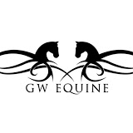

Highbrook Stables is a competition venue offering both horse and rider excellent facilities.
Gayle White is an international show jumper who is devoted to making horse and rider combinations compete to the best of their ability.
Highbrook Stables, Lyss Place, Hawkley Road, West Liss, Hampshire, GU33 6JP
07771 908816

SUNDAY NOVEMBER 21st 2021
ALL CLASSES TO BE HELD IN INDOOR ARENA 9.30am Start

At this show riders and ponies/horses can dress up in all classes for Children In Need – Theme is Superheroes this year but any fancy dress is acceptable and lots of spots! Normal competition wear is still acceptable as well. £2 from each entry fee will be donated to Children In Need. Please come and support us. Entries via website please and you can add extra classes on the day if already entered www.brendonpyecombe.co.uk

Class 15: Marvellous Mare . Sponsored by: Equifun Club
Any sized mare, open to all ridden non lead rein. Winner qualifies for Championship after Class 22

Class 16: Marvellous Mare Sponsored by: Spidge Photography
Any sized mare, open to all lead reins & in hand. Winner qualifies for Championship after class 22

Class 17: Gorgeous Gelding Sponsored by: Leah Lynch Equestrian
Any sized gelding, open to all ridden non lead rein. Winner qualifies for Championship after Class 22

Class 18: Gorgeous Gelding Sponsored by: Baileys Horse Transport
Any sized gelding, open to all lead reins & in hand. Winner qualifies for Championship after Class 22

Class 19: Pony Club Pony – (approx 11.30am) Sponsored by: Tracey Forrest
Small x-poles jump included and bending cones. Will be split into lead rein & non lead rein
if sufficient entries. Winner qualifies for Championship after class 22.

Class 20: The Pony The Judge Would Like To Take Home Sponsored by: Glenbeigh Stud
Open to all. Will be split into lead rein / in hand and non lead rein if sufficient entries. Winner qualifies
for Championship after Class 22.

Class 21: Best Rider – Non Lead Rein (approx 1pm) Sponsored by: Mates Rates Transport
Open to all ages. May be split if sufficient entries. Cantering in individual show optional.
Winner qualifies for Championship after Class 22.

Class 22: Best Rider Sponsored by: Tracy Cottrell Designs
Lead Rein Only. Judged on rider ability. Winner qualifies for Championship after Class 22.

CHAMPIONSHIP – Open to all winners of classes 15-22, no entry fee payable. Rosettes to all.
Sponsored by: Jane and Alice Phillips of A.P. Equestrian

Class 23: Bottom Hole X-Poles Clear Round. Sponsored by: Accountancy & Business Matters
No spreads. Can be led/assisted. Ponies can do this class with mulitple riders. Ponies must
have lead reins attached to nosebands. All competitors will receive a rosette in this class.

Class 24: Pony and Paws Fun Class – Sponsored by: New Street Garage & Clare Chapman
Open to all children with a dog. Pony and rider to jump first half of small x-pole jumps and
then dismount and lead dog over rest of course. Dogs can have different child to run with if they
want. (adults can assist younger children!). Treat prize to the dog with most coloured spots.
Class will be split into 8 years & under and 9 years and over.

Class 25: X-Poles Jumping – Sponsored by: T & P Equestrian
Approx 30cm-40cm. No spreads. Can be led/assisted. Ponies can do this class with two
different riders. Ponies must have lead reins attached to nosebands. All double clears will
share equal 1st and receive medal. All competitors will receive a rosette in this class.

Rosettes, Trophies, Medal & Sashes in all classes.
Rosettes to all competitors in all classes 15-22
Entry Fees for all classes: £10.00 except Clear Round £7.00. First Aid £3 per rider.
No group cantering in any showing classes. Cantering in individual show optional.
Lead Rein classes are suitable for disabled competitors who are most welcome.
If insufficient entries some classes may be amalgamated. General Brendon Pyecombe Show Rules Apply.

Are you constantly questioning the striding in your distances that you have built at home?
Are you a trainer coaching various heights of horses and ponies and want to build true distances that are safe and relative to competitions?
Are you a parent at a loss of what the strides should be?
Do you walk the course and question how many strides you should be riding?
Do you worry that you are about to send your child or horse down a distance and have no idea what the strides are?
Are you a show centre or arena hire facility that would like to display and educate riders on correct distances?

Any of the above ring true?
You need AccuStride in your arena!
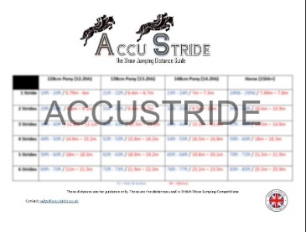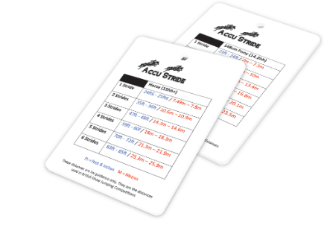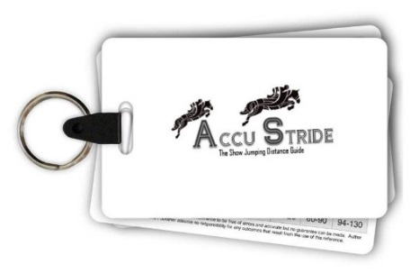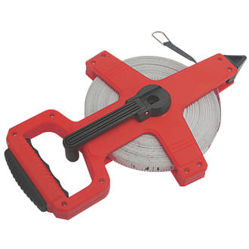

www.AccuStride.co.uk

We welcome your enquiry and hope to satisfy your requirements in the best possible manner. You can contact us in the following ways:
Office: 01892 730378 Mobile: 07712 400262

MANY THANKS TO THE SPONSORS WHO HAVE KINDLY SPONSORED ROSETTES, SASHES, TROPHIES & LUCKY DIP PRIZES

MANY THANKS TO THE FOLLOWING PRIVATE SPONSORS
FOR YOUR SUPPORT:

CLARE CHAPMAN & FAMILY
MS EMMA COOK
PIPPA WOODALL
JANE & ALICE PHILLIPS
GLENBEIGH STUD

AND BIG THANK YOU TO OUR ANONYMOUS SPONSORS AND COMPANIES THAT CONTRIBUTE
TOWARDS THE TABLE TOP SALE,
LUCKY DIPS AND CAKE SALES.

FANCY DRESS PRIZES -
AWARDED IN ALL ARENA EVENTING CLASSES AND JUMPING CLASSES ON SATURDAY & SUNDAY AT
JUDGES DISCRETION

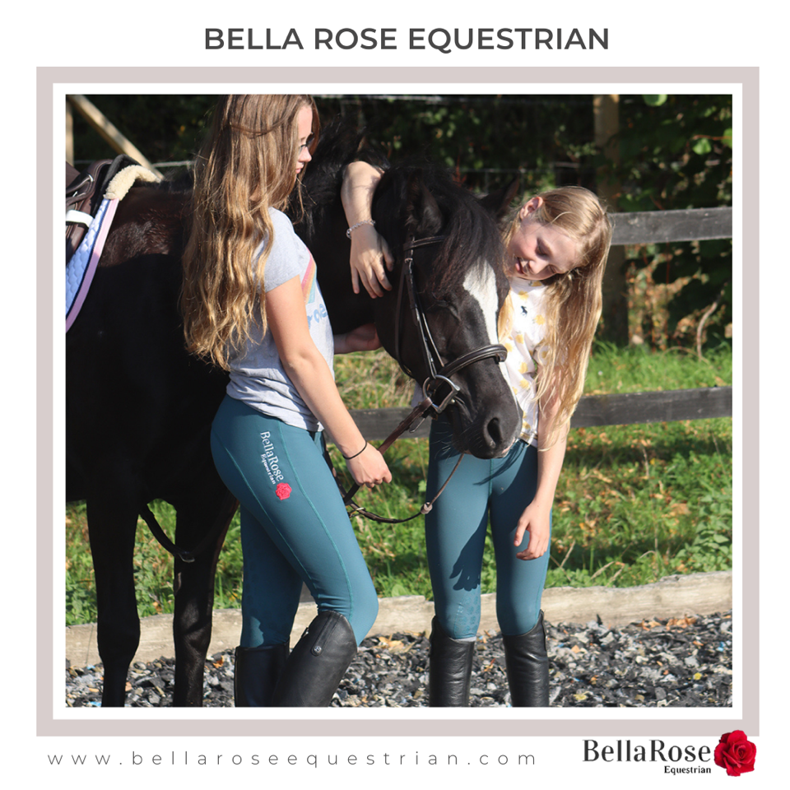

A P EQUESTRIAN
Alice Phillips owns a competiton and schooling livery premises covering Sussex and Hamphire areas. Alice also has the facliity for sales livery.
Can ride at shows or at home. Any problematic/ young green horses/ ponies. Available for breaking in all different types of horses.
Calm professional service and many years experience in backing and producing youngsters.
07930 420577 Or email: alicephillips93@hotmail.com.

Sunshine Tour Championships

The All England Showground, Hickstead
September 2022

This show is a qualifier for The Sunshine Tour Championships held at The All England Jumping Course, Hickstead in September 2022. The Championships are for unaffiliated and amateur competitors in Eventer’s Challenge from 60cm through to 1m.

Qualification: 1st – 4th place. Qualification does not pass down the line.

Bring your own Qualification Form available from www.sunshinetour.co.uk or ask the Secretary if they have any spares available.

Rules and restrictions apply, please check the website www.sunshinetour.co.uk for Terms & Conditions.

NEW FOR 2022
ARENA EVENTING BRITISH EVENTING QUALIFIERS.
80cm, 90cm & 1m
Members & Non Members of BE can qualify. More details at Secretary’s office. Collect qualifying card from office.

BRENDON SADDLERY &
PYECOMBE SHOWS

Extensive range of all horse & rider equipment
available instore and on line.

HORSE & RIDER COMPETITION WEAR
Ariat, Kingsland, Schockemohle, B Vertigo, Veredus, Equiline, Prestige,
Whitaker, Stephens, Horseware, Cavallo, Gallop Equestrian, Le Mieux,
Horse Health, TRM Supplements.
TECH stirrups, HKM, Stubben, Mark Todd, GPA Hats, Airowear, KEP,
Uvex, Chillout, Charles Owen, Harcour, Montar.
Horse First, Equine America, Omega Equine, Net-tex.
Superb selection of Show Shirts and Breeches
Padded Ears, Bridles and Leather Accessories,
Veredus Horse Boots, Hobbles, Travel Accessories.
Feed – Baileys, Dengie, Dodson & Horrell, Top Spec, Allen & Paige
All veterinary products, Supplements & Wormers.
All available in store and on line.
PYECOMBE SHOWS
Affiliated BS Shows for Horses and Ponies from March to October, BD & Unaffiliated Dressage. Arena Eventing. Jumping and Showing Shows all year round. All weather surfaces, hard standing parking, Café & Clubroom.
HORSES FOR SALE
Young horses suitable for show jumping, dressage and eventing. Please contact Shirley Light on 07968 847025

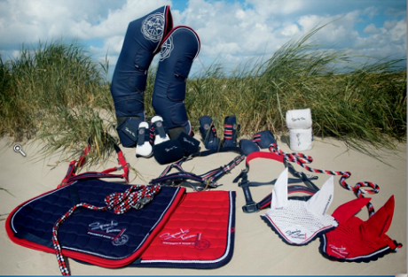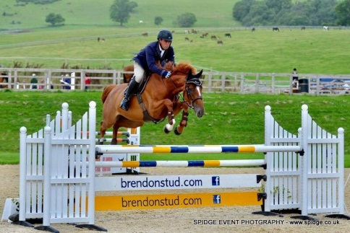
brendonstud.com - 07968 847025 Horses for Sale & At Stud

