SEEL ‘RIVER LODGE EQUESTRIAN’
ARENA EVENTING
CHAMPIONSHIP SCHEDULE
Including Senior BS Show & Unaffiliated Jumping

SATURDAY 24TH & SUNDAY 25TH
FEBRUARY 2018

Saturday 24th – Paris Arena – Arena Eventing Classes.
Saturday 24th – Fred Arena – British Showjumping Senior Show
Sunday 25th – Paris Arena – Arena Eventing Classes
Sunday 25th Fred Arena – Uanffiliated Jumping Classes

At BRENDON STUD, HARESDEAN LANE,
PYECOMBE, WEST SUSSEX. BN45 7EG

Arena Eventing Course will be run in the Paris Arena and will extend
into the Paris Warm up Arena for all classes.

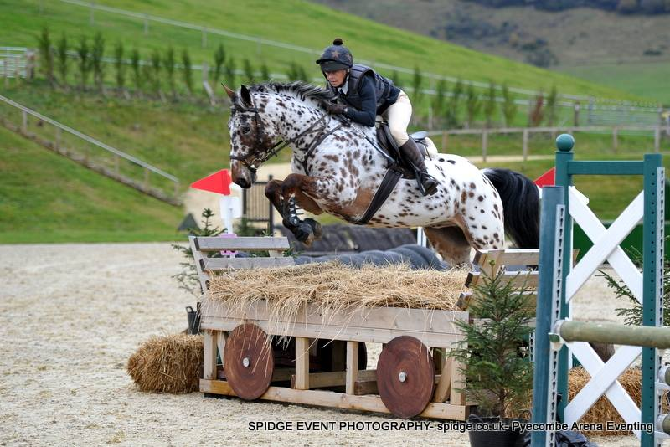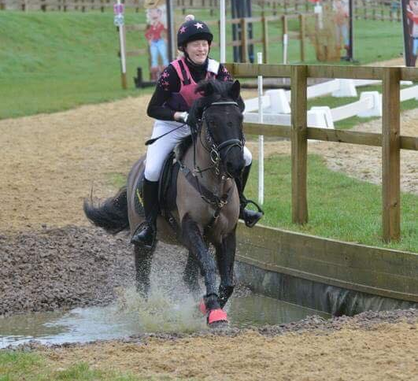

SATURDAY 24th FEBRUARY 2018
PARIS ARENA – 9am Start (maybe 8.30):

Class 1 - 70cm ARENA EVENTING CLASS.
Open to any horse/pony & rider combination. Approx 16 fences in course. Pre entry only. Water splash option available and only middle part of devils dyke to be jumped. 4 second penalty added for each refusal in non-timed part of course. 4 second penalty added for knockdown at any fence on course. 1st 10 gain points for Pyecombe Points League being presented after class 2. Rosettes 1st-10th and Brendon Saddlery Vouchers to the winners. Entry Fee: £20

Class 2 - DODSON & HORRELL 70CM ARENA EVENTING CHAMPIONSHIP.
Section A: Riders aged 15 years & under on day of event.
Section B: Riders aged 16 years and over on day of event.
Open to horse/pony & rider combinations that have competed in a 70cm or 75cm class at Pyecombe between October 2017 and February 2018. This class will be split into 2 sections with 2 sets of prizes. Approx 18 fences in course. Pre entry only. Water splash option available and only middle part of devils dyke to be jumped. 4 second penalty added for each refusal in non-timed part of course. 10 second penalty added for knockdown at any fence on course.
1st 10 gain points for Pyecombe Points League being presented after class 2.
Prizes for each section including Championship 1st-10th rosettes and rug to the winner of each section: 1st - £30, 2nd - £25, 3rd £20. Entry Fee: £21

Class 3 - 80cm ARENA EVENTING CLASS.
Class 3A - Riders aged 15 years & under on day of event.
Class 3B - Riders aged 16 years and over on day of event.
Two sets of rosettes. Approx 20 fences in course. Pre-entry only. Water splash option available and only middle and last part of devils dyke to be jumped. 4 second penalty added for each refusal in non-timed part of course. 4 second penalty added for knockdown at any fence on course. (Please note this class is not a qualifier). 1st 10 gain points for Pyecombe Points League being presented tomorrow. Rosettes 1st-10th and Brendon Saddlery Vouchers to the winners. Entry Fee: £22

Class 4 - 90cm ARENA EVENTING CLASS. Entry Fee: £23
Pre-entry only. Water splash option available and only middle and last part of devils dyke to be jumped. 4 second penalty added for each refusal in non-timed part of course. 4 second penalty added for knockdown at any fence on course. (Please note this class is not a qualifier). 1st 10 gain points for Pyecombe Points League being presented tomorrow. Rosettes 1st-10th and Brendon Saddlery Vouchers to the winners.

WARM UP ARENA FOR PARIS ARENA ON SATURDAY WILL BE IN THE FRED ARENA LORRY PARK END AND RIDERS WILL ENTER THE PARIS ARENA VIA THE DOUBLE WOODEN GATES BY THE LORRY PARK.

70 years’ experience and a wealth of expertise are used to formulate our feeds, supplements and herbal products to ensure that your horse is receiving the very best nutrition. Feeds for your equines, canines and many more species.
Available to buy today onsite at Brendon Saddlery
FRED ARENA
SATURDAY FEBRUARY 24TH - 9am Start
We would strongly advise entries are either entered via the website or emailed as limited on daylight so we will restrict number of entries.

Class 5 – 8am - Clear Round.
Open To All. Course height approx. 90cm. All tickets to be purchased before 8.20am. All rounds jumped before 8.45am. All tickets to be purchased on the day. Entry Fee = £7.00

Class 6a - KBIS Insurance Senior British Novice - First Round
Class 6b - Senior 90cm Open
Rule 316. Single Phase. Speed 325mpm. Start Height 90cm. First place rosette kindly sponsored by KBIS Insurance Horses / ponies may only compete in one section. In the event of insufficient entries lower prizes may be withheld. Rule - 76.6. Entry qualifications: to be ridden by Adult, Associate or Junior Members. British Novice: Entry qualifications: to be ridden by Adult, Associate or Junior Members. a) For Horses in Grade C that have not won a total of 125 points. b) For all horses born on or after 1 January 2014 irrespective of points. Horses will only be eligible for double clear qualification to Second Rounds if they reach the age of four years or under in the same calendar year as the British Novice Final - in accordance with Rule 316.6. Full wording in BS Member Handbook 2018. Horses in the class must go in to the jump-off and go clear to gain a double clear round qualification. Open: For registered horses in Grades: A, B & C. Ridden by Adult, Associate or Junior Members who will be aged 12 years or over in the current calendar year. Horses / ponies may only compete in one section. In Category 2 Shows the sections must always be split with two sets of prize money awarded, irrespective of starters.
Prizes: 1st: £40.00, 2nd: £30.00, 3rd: £20.00, 4th: £17.00, 5th: £17.00, Entry Fee = £17.00

Class 7a - Nupafeed Supplements Senior Discovery - First Round
Class 7b - Senior 1.00m Open
Rule 314. Single Phase. Speed 325mpm. Start Height 1.00m. Horses / ponies may only compete in one section. In the event of insufficient entries lower prizes may be withheld. Rule - 76.6. Entry qualifications: to be ridden by Adult, Associate or Junior Members. Discovery: a) For Horses in Grade C that have not won a total of 225 points. b) For all horses born on or after 1 January 2013 irrespective of points. Horses will only be eligible for double clear qualification to Second Rounds if they reach the age of five years or under in the same calendar year as the Discovery Final - in accordance with Rule 314.6. Full wording in BS Member Handbook 2018. Horses in the class must go in to the jump-off and go clear to gain a double clear round qualification. Open: For registered horses in Grades: A, B & C. Ridden by Adult, Associate or Junior Members who will be aged 12 years or over in the current calendar year.
In Category 2 Shows the sections must always be split with two sets of prize money awarded, irrespective of starters.
Prizes: 1st: £40.00, 2nd: £30.00, 3rd: £20.00, 4th: £17.00, 5th: £17.00, Entry Fee = £17.00

Class 8a - Connolly's RED MILLS Senior Newcomers - First Round
Class 8b - Senior 1.10m Open
Rule 312. Single Phase. Speed 325mpm. Start Height 1.10m. First place rosette kindly sponsored by Connolly's RED MILLS. If combined with an open: In the event of 30 or more starters the class will be split with two sets of prize money. Horses / ponies may only compete in one section. In the event of insufficient entries lower prizes may be withheld. Rule - 76.6. Entry qualifications: to be ridden by Adult, Associate or Junior Members. Newcomers: (a) For registered horses in Grade C that have not won a total of 375 points. (b) For all horses born on or after 1st January 2012, irrespective of Points. Full wording in BS Member Handbook 2018. Open: For registered horses in Grades: A, B & C. Ridden by Adult, Associate or Junior Members who will be aged 12 years or over in the current calendar year.
Prizes: 1st: £50.00, 2nd: £35.00, 3rd: £25.00, 4th: £20.00, 5th: £20.00. Entry Fee = £17.00

Class 9 - Equitop Myoplast Senior Foxhunter First Round/1.20m Open
Rule 310. Two Phase. Speed 350mpm. Start Height 1.20m. First place rosette kindly sponsored by Equitop Myoplast. In the event of 30 or more starters the class will be split and two sets of prize money awarded. Horses / ponies may only compete in one section. In the event of insufficient entries lower prizes may be withheld. Rule - 76.6. Foxhunter section: (a) For registered horses in Grade C that have not won a total of 700 points. Four double clears will qualify - in accordance with rule 310.6. (b) For all registered horses born on or after 1 January 2011, irrespective of points. Full wording in BS Member Handbook 2018. Open section: For registered horses ridden by Adult, Associate or Junior Members. If combined with an open: In the event of 30 or more starters the class will be split with two sets of prize money.
Prizes: 1st: £70.00, 2nd: £50.00, 3rd: £40.00, 4th: £30.00, 5th: £20.00 Entry Fee = £20.00

SUNDAY 25TH FEBRUARY 2018
PARIS ARENA – 9am Start (maybe 8.30):

Class 10 – RIVER LODGE EQUESTRIAN 80cm ARENA EVENTING CHAMPIONSHIP
Section A: Riders aged 15 years & under on day of event.
Section B: Riders aged 16 years and over on day of event.
Open to horse/pony & rider combinations that have qualified at Pyecombe, Petley Wood or Coombelands since October 2017. Updated qualifier list on our website. This class will be split into 2 sections with 2 sets of prizes. Approx 20 fences in course. Pre entry only. Water splash option available and only middle and last part of devils dyke to be jumped. 4 second penalty added for each refusal in non-timed part of course. 10 second penalty added for knockdown at any fence on course. 1st 10 gain points for Pyecombe Points League being presented after this class at the Secretary’s.
Prizes for each section including Championship 1st-10th rosettes and rug and sash to the winner of each section:
1st - £50, 2nd - £25, 3rd - £15, 4th - £15 for each section. Entry Fee: £22

Class 11 – RIVER LODGE EQUESTRIAN 90cm ARENA EVENTING CHAMPIONSHIP
Open to horse/pony & rider combinations that have qualified at Pyecombe, Petley Wood or Coombelands since October 2017. Updated qualifier list on our website. Approx 20 fences in course. Pre entry only. Water splash option available and only middle and last part of devils dyke to be jumped. 4 second penalty added for each refusal in non-timed part of course. 10 second penalty added for knockdown at any fence on course. 1st 10 gain points for Pyecombe Points League being presented after this class at the Secretary’s.
Prizes for each section including Championship 1st-10th rosettes and rug and sash to the winner.
1st - £100, 2nd - £60, 3rd £40, 4th £20. Entry Fee: £23

Class 12 – RIVER LODGE EQUESTRIAN 1M ARENA EVENTING CHAMPIONSHIP.
Open to horse/pony & rider combinations that have qualified at Pyecombe, Petley Wood or Coombelands since October 2017. Updated qualifier list on our website. Approx 20 fences in course. Pre entry only. Water splash option available and only middle and last part of devils dyke to be jumped. 4 second penalty added for each refusal in non-timed part of course. 10 second penalty added for knockdown at any fence on course. 1st 10 gain points for Pyecombe Points League being presented after this class at the Secretary’s.
Prizes for each section including Championship 1st-10th rosettes and rug & sash to the winner.
1st - £100, 2nd - £60, 3rd - £40, 4th – £20. Entry Fee: £23

TO ENTER: PLEASE ENTER ONLINE at www.brendonpyecombe.co.uk.

ENTRIES WILL BE TAKEN ON FIRST COME FIRST SERVED BASDIS FOR ARENA EVENTING CLASSES SO PLEASE ENTER EARLY TO AVOID DISAPPOINTMENT.

WARM UP ARENA FOR PARIS ARENA ON SUNDAY WILL BE IN THE FAR END OF THE FRED ARENA AND RIDERS WILL ENTER THE PARIS ARENA FROM THE COLLECTING RING END
(as per previous Arena Eventing Shows).

ARENA EVENTING CLASS RULES:
All classes will be run over a section of Show Jumps followed by a section of simulated cross-country and natural fences (some will be fixed & some will be knockdown fences).
The Cross-country section will be timed.
Winner will be the fastest time over the timed section. All classes will be run under Single Phase.
3 refusals in total – elimination. 1st fall of rider and/or horse – elimination.
Any riding deemed dangerous by judges/steward may incur elimination. Judges decision is final.
BE compliant XC kit must be worn - See Rules 5 & 6. Stop watches and Go-Pro Cameras are not permitted
First Aid - £4 per rider. All entries in advance so individual times can be given.
Standard Brendon Stud Show Rules will apply and added rules for this show are:.
- Horses/ponies must compete at their allocated time slot.
- No horse/pony under the age of four years may compete, and only horses/ponies competing in the show may be ridden on the show ground.
- HATS All riders MUST wear correctly fitting approved protective headgear conforming to VG1, ASTM, PAS 015, SEI, or SNELL E2001, carrying the BSI Kite Mark, which includes retaining harness secured to the shell at more than two points and with no fixed peak. Must be worn and be correctly fastened AT ALL TIMES when mounted.
- HAIR Riders must wear their hair no longer than shoulder length, neatly & firmly secured.
- BODY PROTECTORS MUST BE WORN. Correct riding dress, including light coloured breeches or jodhpurs, must be worn or Cross country colours are allowed to be worn.
- All entries are pre-entry. Once classes are full/times published on website, entries will not be refundable under any circumstances unless we can sell your entries. We will operate a waiting list.
- HOW TO ENTER: All entries must be made online please at www.brendonpyecombe.co.uk.
- Please check website from the day before the show for individual times: www.brendonpyecombe.co.uk

******************************************
MANY THANKS TO OUR LEADING SPONSORS OF THIS EVENT:

RIVER LODGE EQUESTRIAN
River Lodge Equestrian are a dynamic Show Jumping & Eventing Team run by International riders Michelle Kenny and Rafael Sanctuary.
Combined with this, they have a proven record in sourcing and selling horses from across Europe, priding themselves on presenting the most suitable horses and assisting clients with their complete purchase requirements.
RLE have expanded their operation to include a base in the South East of England in addition to their Irish trading stables.
Michelle and Rafael take great pride in the bespoke business services they offer to their clients and partners.
www.rle.ie
Contact: Rafael Sanctuary. Email: info@rle.ie Tel: 07757 680202
FRED ARENA
SUNDAY FEBRUARY 25TH - FRED ARENA – 9am Start

Class 13 - CLEAR ROUND Entry Fee £7
Approx 60cm. Pay and collect ticket from secretary. Rosettes to all clears. Limited to 20 tickets, this
clear round will only run for approx 30 minutes.

Class 14 - 60cm OPEN Entry Fee £11
Open to all horses and ponies. Single phase. Eligible double clears qualify for Cricklands 10 & Under 2’0 Qualifier. Rosettes 1st-6th and all double clears.

Class 15 - 70cm OPEN Entry Fee £11
Open to all horses and ponies. Single phase. Rosettes 1st-6th and all double clears. Cricklands Qualifier.

Class 16 - CLEAR ROUND Entry Fee £7
Approx 70/75cm. £7, collect ticket from secretary. Rosettes to all clears. Limited to 20 tickets, this clear round will only run for approx 30 minutes.

Class 17 – 75/80cm OPEN Entry Fee £11
Open to all horses and ponies. Single phase. Cricklands Qualifier. Rosettes 1st-6th and all double clears.

Class 18 - 80cm OPEN Entry Fee £11
Open to all horses and ponies. Single phase. Cricklands Qualifier. Rosettes 1st-6th and all double clears

TO ENTER: PLEASE ENTER ONLINE at www.brendonpyecombe.co.uk for Jumping Classes. Entries only taken on the day for jumping classes if not full.

JUMPING CLASSES NOTES:
Refusal Faults: 1st and 2nd refusal – 4 faults each. 3rd refusal =elimination.
Fall of horse or rider: Elimination.
Prizes: Rosettes 1st-6th and rosettes to all double clears. Vouchers in ratio to starters.
Entries accepted on the day if spaces allow. Café and saddlery shop open all day on show days.
£4 paramedic charge per rider.

Arena layout for Sunday will be:
Fred arena warm up arena - Car Park end of Fred arena.
Fred arena will be slightly smaller than normal events.
Far end of Fred area: Warm up area for Paris Arena will be the normal far end of Fred arena warm up area.

COLLECT CARD FROM SECRETARY FOR FOLLOWING:

CRICKLANDS QUALIFIERS: - double clears – www.cricklands.com

ALL CLASSES WILL BE SUNSHINE TOUR QUALIFIERS – PLEASE BRING CARD TO SECRETARY’S TO SIGN.

Due to daylight hours we strongly recommend pre-entry on website to guarantee your entry. We will accept entries on the day if space allows.
"BRENDON STUD 2018"
“Breed from a winner to breed a winner”
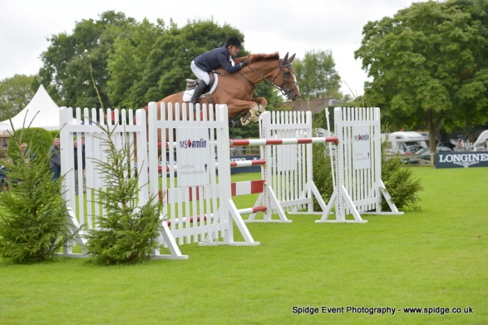

CARETINO GLORY FABRICE VAN OVERIS
Cheenook x Glorieux For Pleasure x Diamant de Semilly
NOBLE WARRIOR WARRATINO
Warrior x Casantos Warrior x Caretino Glory
LORD DON ENVOY Van’t MERELSNEST
Don vhp Z x Hamilton III Elvis ter Putte x Voltaire
CREEVY PACINO CRUISE KLARIS GIDDY UP
Pacino x Cruising Don vhp Z x Caretino Glory
USHER VAN OVERIS Z REGAL DON
Untouchable x Ahorn Don vhp Z x Sebastian III
KLENT KICK ON DONTINO
Warrior x Caretino Glory Don VHP Z x Caretino Glory
SUSSEX DON PANDITO van’t MERELSNEST
Don VHP Z x Hamilton III Plot Blue x Larino x Darco

The above stallions are available AI [fresh or chilled, some frozen]
EVA tested/vaccinated. CEM swabbed.
* Probably the best selection of competition sires with proven bloodlines available in the U.K. *
Follow us on Facebook to keep updated!
HARESDEAN LANE, PYECOMBE, SUSSEX, BN45 7EG, ENGLAND.
E.mail shirleyno2@hotmail.com www.brendonstud.com
TEL: Shirley - 07968 847025 - 01273 844508
BRENDON SADDLERY

Visit our onsite saddlery - located through car park in main barn.

Extensive range of all pony, horse & rider equipment instore and on line.

HORSE & RIDER COMPETITION WEAR
Ariat, Kingsland, Freejump, Schockemohle, GPA
B Vertigo, Veredus, Equiline, Prestige, Whitaker, Stephens, Horseware, HKM, Stubben, Mark Todd, Busse, KEP,
BR Horse Boots, Jin Stirrups, Tech Stirrups,
Jumpers Horse Line, Charles Owen, Gatehouse, Horse First, Equine America, Lincoln, Net-tex, KM Elite.

Superb selection of Show Shirts, Jackets and Breeches.
Large selection of long and short riding boots in stock.
Padded Ears, Bridles and Leather Accessories,
Veredus Horse Boots, Hobbles,

Feed & Shavings – Excellent quality white shavings.
Discount for quantity.
Dodson & Horrell, Baileys, Top Spec, Horsehage,
Pegasus, Mollichaff, Dengie

Tel: 01273 845545 OR BUY ON LINE: www.brendonsaddlery.co.uk

