ARENA EVENTING
CHAMPIONSHIP SCHEDULE

SATURDAY 2nd MARCH
&
SUNDAY 3rd MARCH 2019

At BRENDON STUD, HARESDEAN LANE,
PYECOMBE, WEST SUSSEX. BN45 7EG

Arena Eventing Course will be run in
the Paris Arena and will extend
into the Paris Warm up Arena
for all classes.

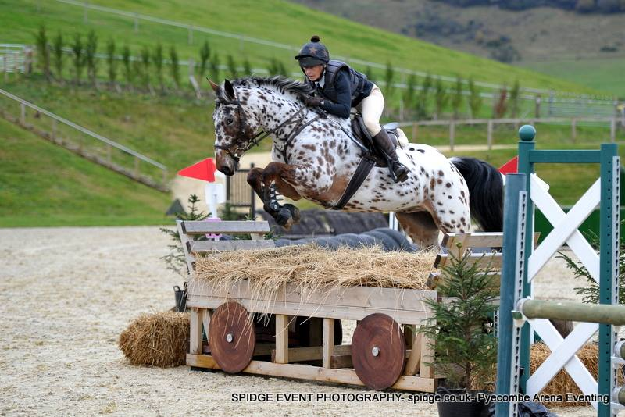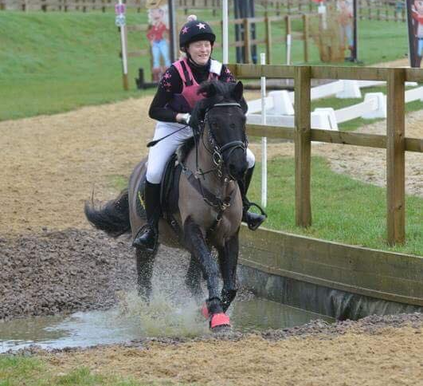

SPIDGE PHOTOGRAPHY
will be in attendance both days -
Sponsors of all Arena Eventing Points Leagues.
ARENA EVENTING CLASS RULES:
All classes will be run over a section of Show Jumps followed by a section of simulated cross-country and natural fences (some will be fixed & some will be knockdown fences).
The Cross-country section will be timed.
Winner will be the fastest time over the timed section. All classes will be run under Single Phase.
4 second penalty added for each refusal in non-timed part of course.
No penalty added for refusal in timed section as you already lose time by refusing.
10 second penalty added for knockdown at any fence on course.
3 refusals in total – elimination. 1st fall of rider and/or horse – elimination.
Any riding deemed dangerous by judges/steward may incur elimination. Judges decision is final.
BE compliant XC kit must be worn - See Rules 5 & 6. Stop watches and Go-Pro Cameras are not permitted
First Aid - £4 per rider. All entries in advance so individual times can be given.
Standard Brendon Stud Show Rules will apply and added rules for this show are:.
- Horses/ponies must compete at their allocated time slot.
- No horse/pony under the age of four years may compete, and only horses/ponies competing in the show may be ridden on the show ground.
- HATS All riders MUST wear correctly fitting approved protective headgear conforming to VG1, ASTM, PAS 015, SEI, or SNELL E2001, carrying the BSI Kite Mark, which includes retaining harness secured to the shell at more than two points and with no fixed peak. Must be worn and be correctly fastened AT ALL TIMES when mounted.
- HAIR Riders must wear their hair no longer than shoulder length, neatly & firmly secured.
- BODY PROTECTORS MUST BE WORN. Correct riding dress, including light coloured breeches or jodhpurs, must be worn or Cross country colours are allowed to be worn.
- All entries are pre-entry. Once classes are full/times published on website, entries will not be refundable under any circumstances unless we can sell your entries. We will operate a waiting list.
- HOW TO ENTER: All entries must be made online please at www.brendonpyecombe.co.uk.
- Please check website from the day before the show for individual times: www.brendonpyecombe.co.uk

******************************************
Omega Equine has built a fantastic range of innovative supplements, which have proved extremely popular with equine consumers including individual leisure horse owners through to Gold Medal winning competition riders.

Current Specialist Blend Products are:
Omega Rice – A well-known Conditioning Feed
Omega Vitality – A natural source of everyday Vitamins and Minerals
Omega Muscle – Nutritional support for natural muscle development
Omega Vita ‘E’ – Supplemental source of natural Vitamin E
Omega Flax Oil – Cold pressed Linseed Oil for Condition
Omega Digest – Gut balancer and digestive aid
Omega Hoof - Supports Natural strong Hoof horn Growth
AVAILABLE TO BUY TODAY AT BRENDON SADDLERY
BRENDON SADDLERY

Visit our onsite saddlery - located through car park in main barn.

Extensive range of all pony, horse & rider equipment instore and on line.

HORSE & RIDER COMPETITION WEAR
Ariat, Kingsland, Schockemohle, GPA, QHP, Harcour,
Veredus, Equiline, Prestige, Whitaker, Stephens, Horseware, HKM, Stubben, Mark Todd, Montar, KEP, Uvex Hats, Champion, Airowear, Tech Stirrups, Jumpers Horse Line, Charles Owen, Omega Equine, Horse First, Equine America, Lincoln, Net-tex, KM Elite.

Superb selection of Show Shirts, Jackets and Breeches.
Large selection of long and short riding boots in stock.
Padded Ears, Bridles and Leather Accessories,
Veredus Horse Boots, Hobbles,

Feed & Shavings – Excellent quality white shavings.
Discount for quantity.
Dodson & Horrell, Baileys, Top Spec, Horsehage,
Pegasus, Mollichaff, Dengie

Tel: 01273 845545 OR BUY ON LINE: www.brendonsaddlery.co.uk

SATURDAY 2ND MARCH 2019
PARIS ARENA – 9am Start (maybe 8.30):

Class 1 - 70cm ARENA EVENTING OPEN CLASS.
Open to any horse/pony & rider combination. Approx 16 fences in course. Pre entry only. Water splash option available and only middle part of devils dyke to be jumped. 4 second penalty added for each refusal in non-timed part of course. 10 second penalty added for knockdown at any fence on course. 1st 10 gain points for Pyecombe Points League being presented after class 2. Rosettes 1st-10th and Brendon Saddlery Vouchers to the winners. Entry Fee: £20

Class 2 - DODSON & HORRELL 70CM ARENA EVENTING CHAMPIONSHIP.
Kindly sponsored by Dodson and Horrell.
Section A: Riders aged 15 years & under on day of event.
Section B: Riders aged 16 years and over on day of event.
Open to horse/pony & rider combinations that have QUALIFIED at Pyecombe between October 2018 and February 2019. This class will be split into 2 sections with 2 sets of prizes. Approx 18 fences in course. Pre entry only. Water splash option available and only middle part of devils dyke to be jumped. 4 second penalty added for each refusal in non-timed part of course. 10 second penalty added for knockdown at any fence on course. 1st 10 gain points for Pyecombe Points League being presented after class 2.
Prizes for each section including Championship 1st-10th rosettes and rug to the winner of each section: 1st - £30, 2nd - £25, 3rd £20. Entry Fee: £22

Class 3 - OMEGA EQUINE 80cm ARENA EVENTING OPEN CLASS.
Class 3A - Riders aged 15 years & under on day of event.
Class 3B - Riders aged 16 years and over on day of event.
Two sets of rosettes. Approx 20 fences in course. Pre-entry only. Water splash option available and only middle and last part of devils dyke to be jumped. 4 second penalty added for each refusal in non-timed part of course. 10 second penalty added for knockdown at any fence on course. (Please note this class is not a qualifier). 1st 10 gain points for Pyecombe Points League being presented tomorrow. Rosettes 1st-10th . Prizes from Omega Equine and Brendon Saddlery Vouchers to the winners. Entry Fee: £22

Class 4 - OMEGA EQUINE 90cm ARENA EVENTING OPEN CLASS.
Pre-entry only. Water splash option available and only middle and last part of devils dyke to be jumped. 4 second penalty added for each refusal in non-timed part of course. second penalty added for knockdown at 10any fence on course. (Please note this class is not a qualifier). 1st 10 gain points for Pyecombe Points League being presented tomorrow. Rosettes 1st-10th and Prizes from Omega Equine and Brendon Saddlery Vouchers to the winners. Brendon Saddlery Vouchers to the winners. Entry Fee: £23

70 years’ experience and a wealth of expertise are used to formulate our feeds, supplements and herbal products to ensure that your horse is receiving the very best nutrition. Feeds for your equines, canines and many more species.
Available to buy today onsite at Brendon Saddlery
Loving Paws Pet Services are based in Lingfield Surrey and run by Sandra and her family with over 40 year of experience and involvement with dogs and other animals.
We are offering a friendly and tailored service to suit you and your pets needs, always treating them as our own.
We walk all of our dogs on a private 25 acre estate and we also have 5 acres of private woodland, where even on the hottest day of the year it stays cool as it is sheltered and in the winter doesn't get very wet\muddy. You can be rest assured that your dog won’t meet any others not known to us on their walk.
​We will discuss your pets preferences at our initial meeting to make sure they get the best from their walk/stay with us. We are fully insured.

Email:info@lovingpaws.co.uk Telephone: 07753 242977 www.lovingpaws.co.uk

DEVULDER EQUESTRIAN
Devulder Equestrian is an equestrian teaching, training and problem solving business
that can help you improve all aspects of your riding and relationship.
Based in Surrey and regularly running clinics in Sussex and Surrey at competition venues.
Email: devulder_equestrian@hotmail.com
Tel: 07753 242977
Find us on facebook to keep updated with news and events
https://www.facebook.com/devulderequestrian/

​

SUNDAY 3RD MARCH 2019
PARIS ARENA – 9am Start (maybe 8.30):

Class 5A –PANGDEAN OLD BARN 80cm ARENA EVENTING CHAMPIONSHIP –
15 YEARS & UNDER - Kindly Sponsored by Pangdean Old Barn

Class 5B –BRITANIACREST RECYCLING 80cm ARENA EVENTING CHAMPIONSHIP – 16 YEARS & OVER. Kindly Sponsored by Britaniacrest Recycling.
Open to horse/pony & rider combinations that have QUALIFIED at Pyecombe between October 2018 and February 2019. Updated qualifier list on our website. This class will be split into 2 sections with 2 sets of prizes. Approx 20 fences in course. Pre entry only. Water splash option available and only middle and last part of devils dyke to be jumped. 4 second penalty added for each refusal in non-timed part of course. 10 second penalty added for knockdown at any fence on course.
1st 10 gain points for Pyecombe Points League being presented after this class at the Secretary’s.
Prizes for each section including Championship 1st-10th rosettes and rug and sash to the winner of each section:
1st - £75, 2nd - £50, 3rd - £30, 4th - £20. Entry Fee: £23

Class 6 – DEVULDER EQUESTRIAN & LOVING PAWS 90cm ARENA EVENTING CHAMPIONSHIP Kindly Sponsored by Loving Paws and Devulder Equestrian
Open to horse/pony & rider combinations that have QUALIFIED at Pyecombe between October 2018 and February 2019. Updated qualifier list on our website. Approx 20 fences in course. Pre entry only. Water splash option available and only middle and last part of devils dyke to be jumped. 4 second penalty added for each refusal in non-timed part of course. 10 second penalty added for knockdown at any fence on course. 1st 10 gain points for Pyecombe Points League being presented after this class at the Secretary’s.
Prizes include Championship 1st-10th rosettes and rug and sash to the winner.
1st - £75, 2nd - £50, 3rd - £30, 4th - £20. Entry Fee: £23

Class 7 – OMEGA EQUINE 1M ARENA EVENTING CHAMPIONSHIP.
Kindly sponsored by Omega Equine
Open to horse/pony & rider combinations that have QUALIFIED at Pyecombe between October 2018 and February 2019. Updated qualifier list on our website. Approx 20 fences in course. Pre entry only. Water splash option available and all 3 part of devils dyke to be jumped (x-pole going in). 4 second penalty added for each refusal in non-timed part of course. 10 second penalty added for knockdown at any fence on course. 1st 10 gain points for Pyecombe Points League being presented after this class at the Secretary’s.
Prizes include Championship 1st-10th rosettes and rug & sash to the winner.
1st - £75, 2nd - £50, 3rd - £30, 4th - £20. Entry Fee: £23

Class 8 - 1.10M ARENA EVENTING OPEN CLASS
Approx 20 fences in course. Pre-entry only. Water splash option available and all 3 part of devils dyke to be jumped (x-pole going in).
Rosettes 1st-10th and Prizes from Omega Equine and Brendon Saddlery Vouchers to the winners. Brendon Saddlery Vouchers to the winners. Entry Fee: £23

TO ENTER: PLEASE ENTER ONLINE at www.brendonpyecombe.co.uk.

01293 820021

Pangdean offers an intimate and atmospheric function venue set against the backdrop of the rolling South Downs.
At the heart of our working farm lies our magnificent oak-framed Sussex barn. Built in 1720, the Old Barn has been lovingly restored to offer a unique wedding or function venue that is exclusively yours for the day.
Flexibility for large or small events. We are able to set up our function spaces in a variety of formats to suit your needs. Whether you want a formal or informal wedding, corporate fun-day, simple barn dance, golden wedding party or christening celebration, be assured we will do all we possibly can to make your event truly special
Pangdean Farm, Pyecombe, West Sussex. BN45 7FJ
www.pangdean.com
Email us: gill@pangdean.com Call: 01273 843302

