ARENA EVENTING
CHAMPIONSHIP SCHEDULE

SATURDAY 29th FEBRUARY
&
SUNDAY 1st MARCH 2020
Including Unaffiliated Jumping
On Saturday.

At BRENDON STUD, HARESDEAN LANE,
PYECOMBE, WEST SUSSEX. BN45 7EG

Arena Eventing Course will be run in the
Paris Arena and will extend into the Paris Warm up Arena for all classes.

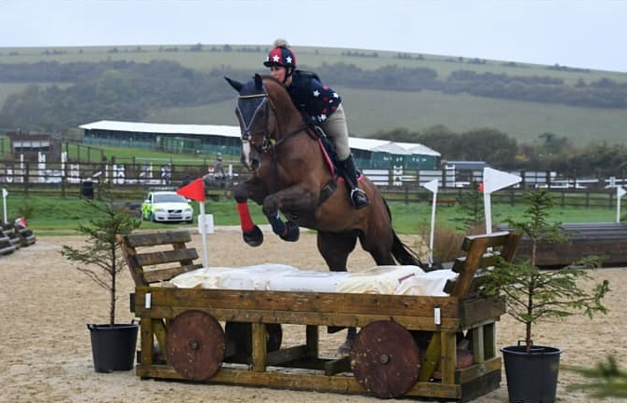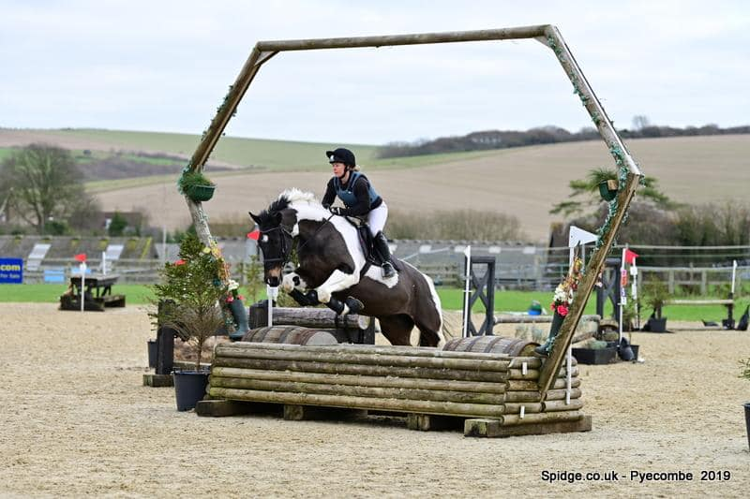

SPIDGE PHOTOGRAPHY
will be in attendance both days -
Sponsors of all Arena Eventing Points Leagues.
ARENA EVENTING CLASS RULES:
All classes will be run over a section of Show Jumps followed by a section of simulated cross-country and natural fences (some will be fixed & some will be knockdown fences).
The Cross-country section will be timed.
Winner will be the fastest time over the timed section. All classes will be run under Single Phase.
4 second penalty added for each refusal in non-timed part of course.
No penalty added for refusal in timed section as you already lose time by refusing.
10 second penalty added for knockdown at any fence on course.
3 refusals in total – elimination. 1st fall of rider and/or horse – elimination.
Any riding deemed dangerous by judges/steward may incur elimination. Judges decision is final.
BE compliant XC kit must be worn - See Rules 5 & 6. Stop watches and Go-Pro Cameras are not permitted
First Aid - £4 per rider. All entries in advance so individual times can be given.
Standard Brendon Stud Show Rules will apply and added rules for this show are:.
- Horses/ponies must compete at their allocated time slot.
- No horse/pony under the age of four years may compete, and only horses/ponies competing in the show may be ridden on the show ground.
- HATS All riders MUST wear correctly fitting approved protective headgear conforming to VG1, ASTM, PAS 015, SEI, or SNELL E2001, carrying the BSI Kite Mark, which includes retaining harness secured to the shell at more than two points and with no fixed peak. Must be worn and be correctly fastened AT ALL TIMES when mounted.
- HAIR Riders must wear their hair no longer than shoulder length, neatly & firmly secured.
- BODY PROTECTORS MUST BE WORN. Correct riding dress, including light coloured breeches or jodhpurs, must be worn or Cross country colours are allowed to be worn.
- All entries are pre-entry. Once classes are full/times published on website, entries will not be refundable under any circumstances unless we can sell your entries. We will operate a waiting list.
- HOW TO ENTER: All entries must be made online please at www.brendonpyecombe.co.uk.
- Please check website from the day before the show for individual times: www.brendonpyecombe.co.uk

******************************************
Omega Equine has built a fantastic range of innovative supplements, which have proved extremely popular with equine consumers including individual leisure horse owners through to Gold Medal winning competition riders.

Current Specialist Blend Products are:
Omega Rice – A well-known Conditioning Feed
Omega Vitality – A natural source of everyday Vitamins and Minerals
Omega Muscle – Nutritional support for natural muscle development
Omega Vita ‘E’ – Supplemental source of natural Vitamin E
Omega Flax Oil – Cold pressed Linseed Oil for Condition
Omega Digest – Gut balancer and digestive aid
Omega Hoof - Supports Natural strong Hoof horn Growth
AVAILABLE TO BUY TODAY AT BRENDON SADDLERY
BRENDON SADDLERY &
PYECOMBE SHOWS
Extensive range of all horse & rider equipment

HORSE & RIDER COMPETITION WEAR
Acavello, Airowear, Ariat, Cavallo, Champion, Charles Owen, Chillout, Equiline, Equine America, GPA, Harcour, HKM, Horse First, Horseware, JHL, KEP, Kingsland, Le Mieux, Legacy, Lincoln, Mark Todd, Montar, NAF, Net-tex, Omega, Prestige, QHP, Roeckl, Schockemohle, Stephens, Stubben, TECH, Uvex, Veredus, Whitaker, Woof.
Superb selection of Breeches, Show Shirts and Show Jackets.
Yard wear, stable and yard equipment. Lotions & Potions
Padded Ears, boots, bridles and leather accessories,
Headcollars including foal slips, lead ropes & Hobbles,
All available in store and on line.

PYECOMBE SHOWS
Affiliated BS Shows for Horses and Ponies from February to October.
BD & Unaffiliated Dressage. Arena Eventing.
Unaffiliated Jumping and Showing Shows all year round.
All weather surfaces, hard standing parking, Café, saddlery & Clubroom.

“SALES”
“EXPERIENCE”
HORSES FOR SALE
Young horses suitable for show jumping, dressage and eventing. Please contact Shirley Light on 07968 847025

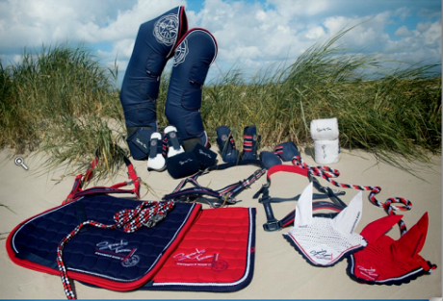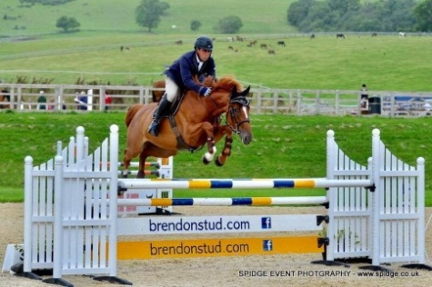

brendonstud.com - 07968 847025 Horses for Sale & At Stud
brendonsaddlery.co.uk - 01273 845545 Online & In-Store brendonpyecombe.co.uk - 01273 844508 Shows & Schedules

SATURDAY 29th FEBRUARY 2020
PARIS ARENA – 9am Start (maybe 8.30):

Class 1 - 70cm ARENA EVENTING OPEN CLASS.
Open to any horse/pony & rider combination. Approx 16 fences in course. Pre entry only. Water splash option available and only middle part of devils dyke to be jumped. 4 second penalty added for each refusal in non-timed part of course. 10 second penalty added for knockdown at any fence on course. 1st 10 gain points for Pyecombe Points League being presented after class 2. Rosettes 1st-10th and Brendon Saddlery Vouchers to the winners. Entry Fee: £22

Class 2A –CHERRY TREE KENNELS 70cm ARENA EVENTING CHAMPIONSHIP –
15 YEARS & UNDER - Kindly Sponsored by Cherry Tree Kennels.

Class 2A –MR MOT 70cm ARENA EVENTING CHAMPIONSHIP –
16 YEARS & OVER. Kindly Sponsored by MR MOT
Open to horse/pony & rider combinations that have QUALIFIED at Pyecombe between October 2019 and February 2020. This class will be split into 2 sections with 2 sets of prizes. Pre entry only. Water splash option available and only middle part of devils dyke to be jumped. 4 second penalty added for each refusal in non-timed part of course. 10 second penalty added for knockdown at any fence on course. 1st 10 gain points for Pyecombe Points League being presented after class 2.
Prizes for each section including Championship 1st-10th rosettes and rug to the winner of each section: 1st - £30, 2nd - £25, 3rd £20. Entry Fee: £22

Class 3 - 80cm ARENA EVENTING OPEN CLASS.
Class 3A - Riders aged 15 years & under on day of event.
Class 3B - Riders aged 16 years and over on day of event.
Two sets of rosettes. Approx 20 fences in course. Pre-entry only. Water splash option available and only middle and last part of devils dyke to be jumped. 4 second penalty added for each refusal in non-timed part of course. 10 second penalty added for knockdown at any fence on course. (Please note this class is not a qualifier). 1st 10 gain points for Pyecombe Points League being presented tomorrow. Rosettes 1st-10th, Brendon Saddlery Vouchers to the winners. Entry Fee: £23

Class 4 - 90cm ARENA EVENTING OPEN CLASS.
Pre-entry only. Water splash option available and only middle and last part of devils dyke to be jumped. 4 second penalty added for each refusal in non-timed part of course. second penalty added for knockdown at 10any fence on course. (Please note this class is not a qualifier). 1st 10 gain points for Pyecombe Points League being presented tomorrow. Rosettes 1st-10th and Brendon Saddlery Vouchers to the winners. Entry Fee: £23

Spacious dog boarding kennels, cattery and pet day care centre, set in ten acres of beautiful countryside.
Located in the heart of Mid Sussex, we are ideally placed to provide a fun, relaxed and comfortable stay for your pet whilst you are away.
Tel: 01444 811 511 www.cherrytreekennels.com
UNAFFILIATED JUMPING IN FRED ARENA
SATURDAY 29th FEBRUARY – 9.00am Start:

Class 5 - CLEAR ROUND Entry Fee £8
Approx 60cm. Pay and collect ticket from secretary. Rosettes to all clears. Limited to 20 tickets, this
clear round will only run for approx 30 minutes.

Class 6 - 60cm OPEN - approx 9.30am. Entry Fee £12
Open to all horses and ponies. Single phase. Rosettes 1st-6th and all double clears. Cricklands and Sunshine Tour Qualifier, please collect card from Secretary.

Class 7 - 70cm OPEN – approx 10.30am Entry Fee £12
Open to all horses and ponies. Single phase. Rosettes 1st-6th and all double clears. Cricklands and Sunshine Tour Qualifier, please collect card from Secretary.

Class 8 - 80cm OPEN – not before 12pm Entry Fee £12
Open to all horses and ponies. Single phase. . Rosettes 1st-6th and all double clears. Cricklands and Sunshine Tour Qualifier, please collect card from Secretary.

Class 9 - 90cm OPEN – - approx 1pm/1.30pm. Entry Fee £12
Open to all horses and ponies. Single phase. Rosettes 1st-6th and all double clears. Cricklands and Sunshine Tour Qualifier, please collect card from Secretary.
Class 10 – 1m OPEN – Entry Fee £12
Open to all horses and ponies. Single phase. Rosettes 1st-6th and all double clears. Cricklands and Sunshine Tour Qualifier, please collect card from Secretary.

JUMPING CLASSES NOTES:
Refusal Faults: 1st and 2nd refusal – 4 faults each. 3rd refusal =elimination.
Fall of horse or rider: Judge will advise if allowed to remount and finish course but will incur elimination.
Prizes: Rosettes 1st-6th and rosettes to all double clears. Vouchers in ratio to starters.
Entries can be submitted via email or online via the website. Entries are normally taken on the day for the unaffiliated jumping classes but not guaranteed. Café and saddlery shop open all day on show days.
£4 paramedic charge per rider.

Arena layout for these shows will be:
Jumping classes in Fred arena - your collecting ring/warm up arena will be in the Car Park end of Fred arena.

Far end of Fred area: Warm up area for Paris Arena will be the normal far end of Fred arena warm up area.

COLLECT CARD FROM SECRETARY FOR FOLLOWING:
CRICKLANDS QUALIFIERS: - double clears – www.cricklands.com

Due to daylight hours we strongly recommend pre-entry on website to guarantee your entry. We will accept entries on the day if space allows.

SUNDAY 1st MARCH 2020
PARIS ARENA – 9am Start (maybe 8.30):

Class 11A –OMEGA EQUINE 80cm ARENA EVENTING CHAMPIONSHIP –
15 YEARS & UNDER - Kindly Sponsored by Omega Equine

Class 11B –BRITANIACREST RECYCLING 80cm ARENA EVENTING CHAMPIONSHIP – 16 YEARS & OVER. Kindly Sponsored by Britaniacrest Recycling.
Open to horse/pony & rider combinations that have QUALIFIED at Pyecombe between October 2019 and February 2020. Updated qualifier list on our website. This class will be split into 2 sections with 2 sets of prizes. Approx 20 fences in course. Pre entry only. Water splash option available and only middle and last part of devils dyke to be jumped. 4 second penalty added for each refusal in non-timed part of course. 10 second penalty added for knockdown at any fence on course.
1st 10 gain points for Pyecombe Points League being presented after this class at the Secretary’s.
Prizes for each section including Championship 1st-10th rosettes and rug and sash to the winner of each section:
1st - £75, 2nd - £50, 3rd - £30, 4th - £20. Entry Fee: £23

Class 12 – CLASSIC SECURITY GROUP 90cm ARENA EVENTING CHAMPIONSHIP Kindly Sponsored by Classic Security Group
Open to horse/pony & rider combinations that have QUALIFIED at Pyecombe between October 2019 and February 2020. Updated qualifier list on our website. Approx 20 fences in course. Pre entry only. Water splash option available and only middle and last part of devils dyke to be jumped. 4 second penalty added for each refusal in non-timed part of course. 10 second penalty added for knockdown at any fence on course. 1st 10 gain points for Pyecombe Points League being presented after this class at the Secretary’s.
Prizes include Championship 1st-10th rosettes and rug and sash to the winner.
1st - £75, 2nd - £50, 3rd - £30, 4th - £20. Entry Fee: £23

Class 13 – SUSSEX EQUINE HOSPITAL 1M ARENA EVENTING CHAMPIONSHIP.
Kindly sponsored by Sussex Equine Hospital
Open to horse/pony & rider combinations that have QUALIFIED at Pyecombe between October 2019 and February 2020. Updated qualifier list on our website. Approx 20 fences in course. Pre entry only. Water splash option available and all 3 part of devils dyke to be jumped (x-pole going in). 4 second penalty added for each refusal in non-timed part of course. 10 second penalty added for knockdown at any fence on course. 1st 10 gain points for Pyecombe Points League being presented after this class at the Secretary’s.
Prizes include Championship 1st-10th rosettes and rug & sash to the winner.
1st - £75, 2nd - £50, 3rd - £30, 4th - £20. Entry Fee: £23

Class 14 - 1.10M ARENA EVENTING OPEN CLASS
Approx 20 fences in course. Pre-entry only. Water splash option available and all 3 part of devils dyke to be jumped (x-pole going in).
Rosettes 1st-10th and Brendon Saddlery Vouchers to the winners. Entry Fee: £23

TO ENTER: PLEASE ENTER ONLINE at www.brendonpyecombe.co.uk.

01293 820021

Our security services range from mobile response units to receptionist and concierge services, from licensed static guarding to state-of-the-art CCTV monitoring. Meanwhile, our commercial cleaning services cover everything from graffiti removal and deep cleans through to regular office areas and public spaces.
Contact: Charlotte Thompson at Classic Security (UK) Limited
Classic House, Unit 16, Alfold Business Centre, Loxwood Road, Alfold, Cranleigh, Surrey. GU6 8HP. Telephone: 08445 610 578
Email: sales@classicsecurity.co.uk www.classicsecurity.co.uk

We care for and about horses. Our practice is able to provide clients throughout Sussex with quality vet care from a team who ALL deal exclusively with equines. Dentistry, Diagnostic Services, Hospitalisation Facilities, Internal Medicine, Laboratory Services, Lameness Evaluation, Surgical Facilities.
Full hospital back up facility for all major procedures. Brendon Stud Recommended Stud Vets.
All stud work procedures including Embryo Transfer.
Tel: 01903 883050 www.sussexequinehospital.co.uk
BILLINGSHURST ROAD, ASHINGTON, WEST SUSSEX, RH20 3BB

Located in the heart of Burgess Hill’s industrial estate, Mr MOT can offer you all the MOT services that you require with a free smile to go with it. Mr MOT prides itself in only offering MOT tests – we don’t do repairs, we don’t sell spares, which means that you can be safe in the knowledge that we won’t try and sell you other services. This means that we provide you a completely unbiased MOT test.
Cars and motorbikes, light commercial vans, classic & vintage cars.
Phone now to book your MOT or book via www.mrmot.co.uk Unit 7, Teknol House, Victoria Road, Burgess Hill.
01444 254000

