SATURDAY 10TH & SUNDAY 11TH APRIL 2021

SEEL ‘K CRUMLEY CONSTRUCTION’
& ‘OMEGA EQUINE’
ARENA EVENTING
CHAMPIONSHIP SCHEDULE
(open sections in all Championships due to restricted qualification
period this season in all classes).

SATURDAY 10TH & SUNDAY 11TH APRIL 2021

Saturday 10th – Paris Arena – Arena Eventing Classes.
Saturday 10th – Fred Arena – Pony BS Show
Sunday 11th – Paris Arena – Arena Eventing Classes
Sunday 11th Fred Arena – Senior BS Show
(BS shows separate schedule available on website)

At BRENDON STUD, HARESDEAN LANE,
PYECOMBE, WEST SUSSEX. BN45 7EG

Arena Eventing Course will be run in the Paris Arena and will extend
into the Paris Warm up Arena for all classes.

Winner of 80cm Senior, 90cm and 1m SEEL Qualified Championships
will each receive 2 Free Ball Tickets to SEEL Ball in November.

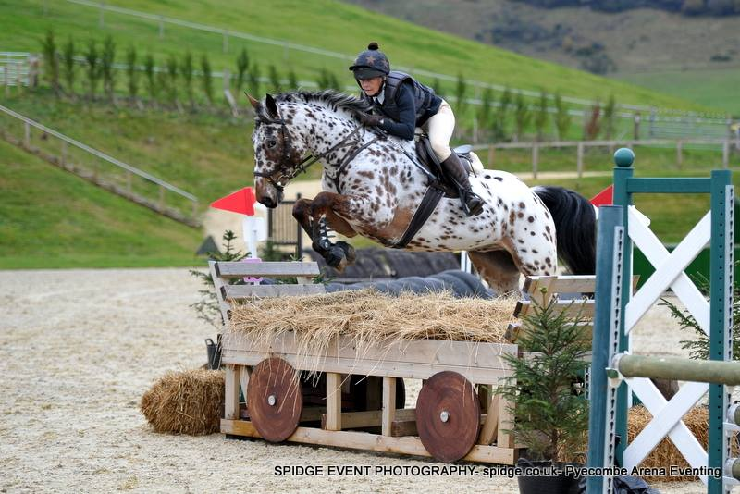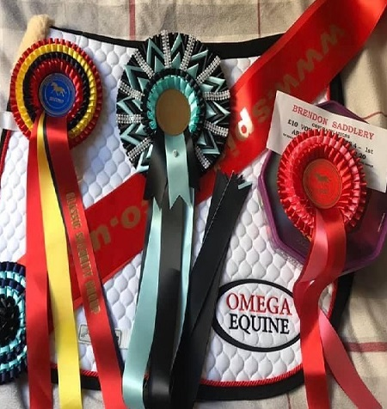

Omega Equine has built a fantastic range of innovative supplements, which have proved extremely popular with equine consumers including individual leisure horse owners through to Gold Medal winning competition riders.

Current Specialist Blend Products are:
Omega Rice – A stabilised Rice bran and Linseed Pellet Conditioning Feed
Omega Muscle – Nutritional support for natural muscle development
Omega Vita ‘E’ – A natural Vitamin E supplement for ultimate muscle health
Omega Ultra Oil – 6 nutritious oils included for optimum energy & condition
Omega Ulsoothe – Naturally supporting gastric and digestive health
Omega Digest – Gut balancer and digestive aid for managing equine stress
Omega Vitality – A natural source of everyday Vitamins and Minerals
Omega Flexology – Naturally supporting bone and joint health
Omega Glucosamine 12,000 with MSM & HA – Supports Joint Health
Omega Flax Oil – Cold pressed Linseed Oil for Condition
Omega Hoof - Supports Natural strong Hoof horn Growth
Omega Boswelia – Significant support for joint movement & mobility
Omega Respirair – Powerful combination of ingredients for respiratory health
Omega ZenCalm – Nutritional support for Anxiety, Stress & Excitability.
Omega Electrolytes – Replenish lost electrolytes to maintain general health.

FULL RANGE OF SUPPLEMENTS AVAILABLE
TO BUY TODAY AT BRENDON SADDLERY

SATURDAY 10TH APRIL 2021
PARIS ARENA – 9am Start (maybe 8.30):

Class 21 - OMEGA EQUINE 70CM OPEN ARENA EVENTING CHAMPIONSHIP.
Section 21A: Riders aged 15 years & under on day of event.
Section 21B: Riders aged 16 years and over on day of event.
Open to ALL horse/pony & rider combinations, NO QUALIFICATION REQUIRED. This class will be split into 2 sections with 2 sets of prizes. Approx 18 fences in course. Pre entry only. Water splash option available and only middle part of devils dyke to be jumped. 4 second penalty added for each refusal in non-timed part of course. 10 second penalty added for knockdown at any fence on course. 1st 10 gain points for Pyecombe Points League being presented after class.
Prizes for each section including Championship 1st-10th rosettes and rug to the winner of each section: 1st - £30, 2nd - £25, 3rd £20. Entry Fee: £22

Class 22 - BRENDON SADDLERY 80cm OPEN ARENA EVENTING CLASS.
Class 22A - Riders aged 15 years & under on day of event.
Class 22B - Riders aged 16 years and over on day of event.
Two sets of rosettes. Approx 20 fences in course. Pre-entry only. Water splash option available and only middle and last part of devils dyke to be jumped. 4 second penalty added for each refusal in non-timed part of course. 4 second penalty added for knockdown at any fence on course. 1ST 10 from each section can qualify for tomorrow’s championship if space allows. 1st 10 gain points for Pyecombe Points League being presented tomorrow. Rosettes 1st-10th.
Prizes for each section – 1st - £15, 2nd - £10, 3rd £10. Entry Fee: £25

Class 23 - BRENDON SADDLERY 90cm OPEN ARENA EVENTING CLASS.
Pre-entry only. Water splash option available and only middle and last part of devils dyke to be jumped. 4 second penalty added for each refusal in non-timed part of course. 4 second penalty added for knockdown at any fence on course. 1ST 10 can qualify for tomorrow’s championship if space allows. 1st 10 gain points for Pyecombe Points League being presented tomorrow. Rosettes 1st-10th,
Prize:– 1st - £15, 2nd - £10, 3rd £10. Entry Fee: £25

Class 24 - BRENDON SADDLERY 1m OPEN ARENA EVENTING CLASS.
Pre-entry only. Water splash option available and only middle and last part of devils dyke to be jumped. 4 second penalty added for each refusal in non-timed part of course. 4 second penalty added for knockdown at any fence on course. 1ST 10 can qualify for tomorrow’s championship if space allows. 1st 10 gain points for Pyecombe Points League being presented tomorrow. Rosettes 1st-10th.
Prizes:– 1st - £15, 2nd - £10, 3rd £10. Entry Fee: £25

WARM UP ARENA FOR PARIS ARENA ON SATURDAY WILL BE IN THE FRED ARENA LORRY PARK END AND RIDERS WILL ENTER THE PARIS ARENA VIA THE DOUBLE WOODEN GATES BY THE LORRY PARK.

SPIDGE PHOTOGRAPHY
will be in attendance both days -

BUILDING, CARPENTRY & GROUNDWORKS….. IT’S WHAT WE DO….. IF YOU NEED A RELIABLE, EXPERIENCED & HARD WORKING TEAM CONTACT KIERAN
We are a family orientated and run business with historical roots
and experience stemming back to the 1980s in the building and groundwork’s industry. Today we are operating in Sussex & Surrey carrying out Building and Groundwork’s for private individuals, estates, commercial clients and on our own property development projects. We operate in the Residential, Commercial, Education and Equestrian sectors in the Southeast of England.

Our services include all aspects of:
- Building
- Carpentry
- Groundwork’s
- Property Development
- Residential, Equestrian & Commercial

Feel free to contact
Kieran directly on 07801105564
or email: info@crumleyconstruction.co.uk
to discuss all your project requirements.
SUNDAY 11TH APRIL 2021
PARIS ARENA – 9am Start (maybe 8.30):

Class 25 – OMEGA EQUINE JUNIOR 80cm ARENA EVENTING CHAMPIONSHIP
Open to riders aged 15 years and under on day of event. This class will be split into two sections:
Section A – open to combinations not competing in Section B, no qualification required.
Section B – open to combinations that have pre-qualified at either Pyecombe or Petley from October 2020 to April 2021. Updated list on SEEL website and our website. Approx 20 fences in course. Pre entry only. Water splash option available and only middle and last part of devils dyke to be jumped. 4 second penalty added for each refusal in non-timed part of course. 10 second penalty added for knockdown at any fence on course. 1st 10 in each section gain points for Pyecombe Points League being presented after this class at the Secretary’s. Rug and Sash to the winner of Section B. Championship rosettes to 1st 10 in each section. Kindly Sponsored by Omega Equine
Prizes Section A: 1st - £30, 2nd - £20, 3rd - £10, 4th - £10. Entry Fee: £25
Prizes Section B: 1st - £50, 2nd - £25, 3rd - £15, 4th - £15. Entry Fee: £25

Class 26 – K CRUMLEY CONSTRUCTION – SENIOR 80cm ARENA EVENTING CHAMPIONSHIP Kindly Sponsored by K Crumley Construction
Open to riders aged 16 years and over on day of event. This class will be split into two sections:
Section A – open to combinations not competing in Section B, no qualification required.
Section B – open to combinations that have pre-qualified at either Pyecombe or Petley from October 2020 to April 2021. Updated list on SEEL website and our website. Approx 20 fences in course. Pre entry only. Water splash option available and only middle and last part of devils dyke to be jumped. 4 second penalty added for each refusal in non-timed part of course. 10 second penalty added for knockdown at any fence on course. 1st 10 in each section gain points for Pyecombe Points League being presented after this class at the Secretary’s. Rug and Sash to the winner of Section B. Championship rosettes to 1st 10 in each section.
Prizes Section A: 1st - £30, 2nd - £20, 3rd - £10, 4th - £10. Entry Fee: £25
Prizes Section B: 1st - £50, 2nd - £25, 3rd - £15, 4th - £15, 5th- £15. Entry Fee: £25

Class 27 –K CRUMLEY CONSTRUCTION – 90cm ARENA EVENTING CHAMPIONSHIP Kindly Sponsored by K Crumley Construction. This class will be split into two sections:
Section A – open to combinations not competing in Section B, no qualification required.
Section B – open to combinations that have pre-qualified at either Pyecombe or Petley from October 2020 to April 2021. Updated list on SEEL website and our website. Approx 20 fences in course. Pre entry only. Water splash option available and only middle and last part of devils dyke to be jumped. 4 second penalty added for each refusal in non-timed part of course. 10 second penalty added for knockdown at any fence on course. 1st 10 in each section gain points for Pyecombe Points League being presented after this class at the Secretary’s. Rug and Sash to the winner of Section B. Championship rosettes to 1st 10 in each section.
Prizes Section A: 1st - £30, 2nd - £20, 3rd - £10, 4th - £10. Entry Fee: £25
Prizes Section B: 1st - £75, 2nd - £50, 3rd - £25, 4th - £20, 5th- £15. Entry Fee: £25

Class 28 – K CRUMLEY CONSTRUCTION – 1m ARENA EVENTING CHAMPIONSHIP Kindly Sponsored by K Crumley Construction This class will be split into two sections:
Section A – open to combinations not competing in Section B, no qualification required.
Section B – open to combinations that have pre-qualified at either Pyecombe or Petley from October 2020 to April 2021. Updated list on SEEL website and our website. Approx 20 fences in course. Pre entry only. Water splash option available and all 3 part of devils dyke to be jumped (x-pole going in). 4 second penalty added for each refusal in non-timed part of course. 10 second penalty added for knockdown at any fence on course. 1st 10 in each section gain points for Pyecombe Points League being presented after this class at the Secretary’s. Rug and Sash to the winner of Section B. Championship rosettes to 1st 10 in each section.
Prizes Section A: 1st - £30, 2nd - £20, 3rd - £10, 4th - £10. Entry Fee: £25
Prizes Section B: 1st - £75, 2nd - £50, 3rd - £25, 4th - £20, 5th- £15. Entry Fee: £25

Class 29 - BRENDON SADDLERY 1.10M ARENA EVENTING OPEN CLASS
Approx 20 fences in course. Pre-entry only. Water splash option available and all 3 part of devils dyke to be jumped (x-pole going in). 4 second penalty added for each refusal in non-timed part of course. 4 second penalty added for knockdown at any fence on course. Rosettes 1st-10th.
Prizes:– 1st - £15, 2nd - £10, 3rd £10. Entry Fee: £25

WARM UP ARENA FOR PARIS ARENA ON BOTH DAYS WILL BE THE LORRY PARK END OF THE FRED ARENA AND RIDERS WILL ENTER AND EXIT THE PARIS ARENA VIA THE DOUBLE WOODEN GATES BY THE LORRY PARK.

********************
ALL ROSETTES AND PRIZES WILL BE COLLECTED FROM THE SECRTARY’S ONCE RESULTS ARE ANNOUNCED.
NO MOUNTED ROSETTE PRESENTATIONS TO COMPLY WITH COVID 19 PROTOCOLS
******************************
ARENA EVENTING CLASS RULES:

All classes will be run over a section of Show Jumps followed by a section of simulated cross-country and natural fences (some will be fixed & some will be knockdown fences).
The Cross-country section will be timed.
Winner will be the fastest time over the timed section. All classes will be run under Single Phase.
4 second penalty added for each refusal in non-timed part of course.
No penalty added for refusal in timed section as you already lose time by refusing.
10 second penalty added for knockdown at any fence on course.
3 refusals in total – elimination. 1st fall of rider and/or horse – elimination.
Any riding deemed dangerous by judges/steward may incur elimination. Judge’s decision is final.
BE compliant XC kit must be worn - See Rules 5 & 6. Stop watches and Go-Pro Cameras are not permitted
First Aid - £5 per rider. All entries in advance so individual times can be given.

Standard Brendon Stud Show Rules will apply and added rules for this show are:.
- Horses/ponies must compete at their allocated time slot.
- No horse/pony under the age of four years may compete, and only horses/ponies competing in the show may be ridden on the show ground.
- HATS All riders MUST wear correctly fitting approved protective headgear conforming to VG1, ASTM, PAS 015, SEI, or SNELL E2001, carrying the BSI Kite Mark, which includes retaining harness secured to the shell at more than two points and with no fixed peak. Must be worn and be correctly fastened AT ALL TIMES when mounted.
- HAIR Riders must wear their hair no longer than shoulder length, neatly & firmly secured.
- BODY PROTECTORS MUST BE WORN. Correct riding dress, including light coloured breeches or jodhpurs, must be worn or Cross-country colours are allowed to be worn.
- All entries are pre-entry. Once classes are full/times published on website, entries will not be refundable under any circumstances unless we can sell your entries. We will operate a waiting list.
- HOW TO ENTER: All entries must be made online please at www.brendonpyecombe.co.uk.
- Please check website from the day before the show for individual times: www.brendonpyecombe.co.uk

******************************************
BRENDON SADDLERY &
PYECOMBE SHOWS
Extensive range of all horse & rider equipment

HORSE & RIDER COMPETITION WEAR
Acavello, Airowear, Ariat, Cavallo, Champion, Charles Owen, Chillout, Equiline, Equine America, GPA, Harcour, HKM, Horse First, Horseware,
JHL, KEP, Kingsland, Le Mieux, Legacy, Lincoln, Mark Todd, Montar,
NAF, Net-tex, Omega Equine, Prestige, QHP, Roeckl, Schockemohle,
Snooty Fox, Stephens, Stubben, TECH, Uvex, Veredus, Whitaker, Woof.
Superb selection of Breeches, leggings & riding tights.
Show Shirts, Boots & and Show Jackets.
Yard wear, stable and yard equipment, wormers. Lotions & Potions
Padded Ears, boots, bridles and leather accessories,
Headcollars including foal slips, lead ropes & Hobbles,
All available in store and on line.

PYECOMBE SHOWS
Affiliated BS Shows for Horses and Ponies from February to November.
BD & Unaffiliated Dressage. Arena Eventing.
Unaffiliated Jumping and Showing Shows all year round.
All weather surfaces, hard standing parking, Café, saddlery & Clubroom.

“SALES”
“EXPERIENCE”
HORSES FOR SALE
Young horses suitable for show jumping, dressage and eventing. Please contact Shirley Light on 07968 847025

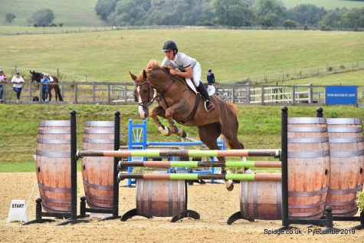
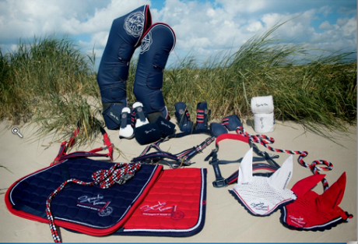

brendonstud.com - 07968 847025 Horses for Sale & At Stud
brendonsaddlery.co.uk - 01273 845545 Online & In-Store brendonpyecombe.co.uk - 01273 844508 Shows & Schedules

